## MILESTONE 1

## Digital image representation

**Image**

An image is a visual representation of something. In information technology, the term has several usages:

An image is a picture that has been created or copied and stored in electronic form. An image can be described in terms of [vector graphics](http://searchwindevelopment.techtarget.com/definition/vector-graphics) or [raster graphics](http://searchcio-midmarket.techtarget.com/definition/raster-graphics). An image stored in raster form is sometimes called a [bitmap](http://searchcio-midmarket.techtarget.com/definition/bit-map). An [image map](http://whatis.techtarget.com/definition/image-map) is a file containing information that associates different locations on a specified image with [hypertext](http://searchsoa.techtarget.com/definition/hypertext) links.

Virtual image, a point or system of points, on one side of a mirror or lens, which, if it existed, would emit the system of rays which actually exists on the other side of the mirror or lens.

## Vector images

One way to describe an image using numbers is to declare its contents using position and size of geometric forms and shapes like lines, curves, rectangles and circles; such images are called vector images.

**Vector image**

Draw circle

centre 0.5, 0.5

radius 0.4

fill-color yellow

stroke-color black

stroke-width 0.05

draw circle

center 0.35, 0.4

radius 0.05

fill-color black

draw circle

center 0.65, 0.4

radius 0.05

fill-color black

draw line

start 0.3, 0.6

end 0.7, 0.6

stroke-color black

stroke-width 0.1

A vector image is resolution independent, this means that you can enlarge or shrink the image without affecting the output quality. Vector images are the preferred way to represent Fonts, Logos and many illustrations.

### Defining shapes

It would have been nice to make a smiling face, instead of the dissatisfied face on the left, by using a Bezier curve, or the segment of a circle this could be achieved, this being a text focusing mainly on raster graphics though, that would probably be too complex.



The preceding description of an image can be seen as a “cooking recipe” for how to draw the image, it contains geometrical primitives like lines, curves and circles describing color as well as relative size, position and shape of elements. When preparing the image for display is has to be translated into a bitmap image, this process is called rasterization**.**

## Bitmap images

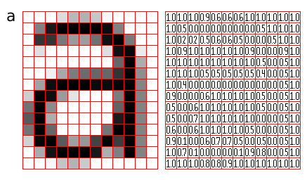Bitmap-, or raster-, images are “digital photographs”, they are the most common form to represent natural images and other forms of graphics that are rich in detail. Bitmap images is how graphics is stored in the video memory of a computer. The term bitmap refers to how a given pattern of bits in a pixel maps to a specific color.

A rasterized form of the letter 'a' magnified 16 times using pixel doubling

The number of horizontal and vertical samples in the pixel grid is called Raster dimensions, it is specified as width x height.

A bitmap images take the form of an array, where the value of each element, called a pixel picture element, correspond to the color of that portion of the image. Each horizontal line in the image is called a scan line.

The letter 'a' might be represented in a 12x14 matrix as depicted in Figure, the values in the matrix depict the brightness of the pixels (picture elements). Larger values correspond to brighter areas whilst lower values are darker.

#### Resolution

Resolution is a measurement of sampling density, resolution of bitmap images gives a relationship between pixel dimensions and physical dimensions. The most often used measurement is ppi, pixels per inch.

A rasterized form of the letter 'a' magnified 16 times, where each pixel is represented as a circle instead of a square.

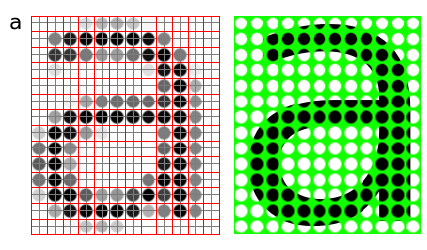

##### Megapixels

Megapixels refer to the total number of pixels in the captured image; an easier metric is raster dimensions which represent the number of horizontal and vertical samples in the sampling grid. An image with a 4:3 aspect ratio with dimension 2048x1536 pixels, contain a total of 2048x1535=3,145,728 pixels; approximately 3 million, thus it is a 3 megapixel image.

**Common/encountered raster dimensions**

| Dimensions | Megapixels | Name | Comment |
| --- | --- | --- | --- |
| 640x480 | 0.3 | VGA | VGA |
| 720x576 | 0.4 | CCIR 601 DV PAL | Dimensions used for PAL DV, and PAL DVDs |
| 768x576 | 0.4 | CCIR 601 PAL full | PAL with square sampling grid ratio |
| 800x600 | 0.4 | SVGA |  |
| 1024x768 | 0.8 | XGA | The currently (2004) most common computer screen dimensions. |
| 1280x960 | 1.2 |  |  |
| 1600x1200 | 2.1 | UXGA |  |
| 1920x1080 | 2.1 | 1080i HDTV | interlaced, high resolution digital TV format. |
| 2048x1536 | 3.1 | 2K | Typically used for digital effects in feature films. |
| 3008x1960 | 5.3 |  |  |
| 3088x2056 | 6.3 |  |  |
| 4064x2704 | 11.1 |  |  |

##### Scaling / Resampling

When we need to create an image with different dimensions from what we have we scale the image. A different name for scaling is resampling, when resampling algorithms try to reconstruct the original continuous image and create a new sample grid.

##### Scaling image down

The process of reducing the raster dimensions is called decimation, this can be done by averaging the values of source pixels contributing to each output pixel.

##### Scaling image up

When we increase the image size we actually want to create sample points between the original sample points in the original raster, this is done by interpolation the values in the sample grid, effectively guessing the values of the unknown pixels

#### Sample depth

The values of the pixels need to be stored in the computer’s memory, this means that in the end the data ultimately need to end up in a binary representation, the spatial continuity of the image is approximated by the spacing of the samples in the sample grid. The values we can represent for each pixel is determined by the sample format chosen.

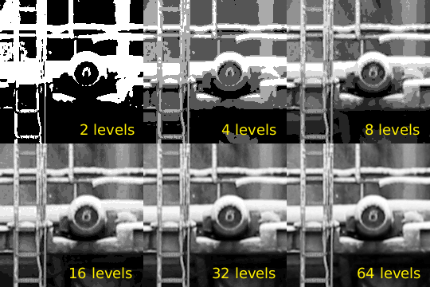

##### 8bit

A common sample format is 8bit integers, 8bit integers can only represent 256 discrete values (2^8 = 256), thus brightness levels are quantized into these levels.

##### 12bit

For high dynamic range images (images with detail both in shadows and highlights) 8bits 256 discrete values does not provide enough precision to store an accurate image. Some digital cameras operate with more than 8bit samples internally, higher end cameras (mostly SLRs) also provide RAW images that often are 12bit (2^12bit = 4096).

##### 16bit

The PNG and TIF image formats supports 16bit samples, many image processing and manipulation programs perform their operations in 16bit when working on 8bit images to avoid quality loss in processing.

##### Floating point

Some image formats used in research and by the movie industry store floating point values. Both "normal" 32bit floating point values and a special format called half which uses 16bits/sample. Floating point is useful as a working format because quantization and computational errors are kept to a minimum until the final render.

Floating point representations often include HDR, High Dynamic Range. High Dynamic Range images are images that include sampling values that are whiter than white (higher values than 255 for a normal 8bit image). HDR allows representing the light in a scene with a greater degree of precision than LDR, Low Dynamic Range images.

#### Colors

The most common way to model color in Computer Graphics is the RGB color model, this corresponds to the way both CRT monitors and LCD screens/projectors reproduce color. Each pixel is represented by three values, the amount of red, green and blue. Thus an RGB color image will use three times as much memory as a gray-scale image of the same pixel dimensions.

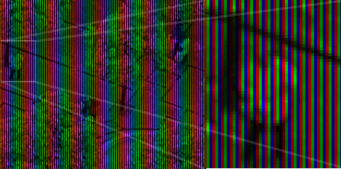

Color image built up of bands of red, green and blue color (This is image illustrates how a laptop display is constructed, note that this image is preferred to be viewed on a computer screen, and not in print.)

One of the most common pixel formats used is 8bit rgb where the red, green and blue values are stored interleaved in memory. This memory layout is often referred to as chunky, storing the components in seperate buffers is called planar, and is not as common.

#### Palette / Indexed images

It was earlier common to store images in a palletized mode, this works similar to a paint by numbers strategy. We store just the number of the palette entry used for each pixel. And for each palette entry we store the amount of red, green and blue light.

**Indexed image**

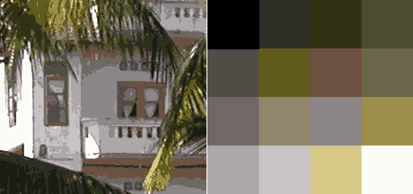

On the left, image using just 16 colors, on the right the palette used for this image. The way an indexed/palette image works is similar to how paint by numbers work.

## File formats and applications

Many applications have their own internal file format, while other formats are more suited for interchange of data. Table ref# lists some common image formats.

**Vector File Formats**

| Extension | Name | Notes |
| --- | --- | --- |
| .ai | Adobe Illustrator Document | Native format of Adobe Illustrator (based on .eps) |
| .eps | Encapsulated Postscript | Industry standard for including vector graphics in print |
| .ps | PostScript | Vector based printing language, used by many Laser printers, used as electronic paper for scientific purposes. |
| .pdf | Portable Document Format | Modernized version of ps, adopted by the general public as 'electronic print version' |
| .svg | Scalable Vector Graphics | XML based W3C standard, incorporating animation, gaining adoption. |
| .swf | Shockwave Flash | Binary vector format, with animation and sound, supported by most major web browsers. |

**Raster File Formats**

| Extension | Name | Notes |
| --- | --- | --- |
| .jpg | Joint Photographic Experts Group | Lossy compression format well suited for photographic images |
| .png | Portable Network Graphics | Lossless compression image, supporting 16bit sample depth, and Alpha channel |
| .gif | Graphics Interchange Format | 8bit indexed bitmap format, is superceded by PNG on all accounts but animation |
| .exr | EXR | HDR, High Dynamic Range format, used by movie industry.. |
| .raw, .raw | Raw image file | Direct memory dump from a digital camera, contains the direct imprint from the imaging sensor without processing with whitepoint and gamma corrections. Different cameras use different extensions, many of them derivatives of TIFF, examples are .nef, .raf and .crw |
| .dgn | Digital Negative | A subset/clarification of TIFF, created by Adobe to provide a standard for storing RAW files, as well as exchanging RAW image data between applications. |
| .tiff, .tif | Tagged Image File Format |  |
| .psd | Photoshop Document | Native format of Adobe Photoshop, allows layers and other structural elements |
| .xcf | Gimp Project File | GIMP's native image format. |

**Functions for Reading, Writing, and Displaying Images**

* Images are essentially two-dimensional matrices, so many MATLAB functions can operate on and display images. The following lists the most useful ones. The sections that follow describe these functions in more detail.

| **Function** | **Purpose** | **Function Group** |
| --- | --- | --- |
| [axis](http://in.mathworks.com/help/matlab/ref/axis.html) | Plot axis scaling and appearance. | Display |
| [image](http://in.mathworks.com/help/matlab/ref/image.html) | Display image (create image object). | Display |
| [imagesc](http://in.mathworks.com/help/matlab/ref/imagesc.html) | Scale data and display as image. | Display |
| [imread](http://in.mathworks.com/help/matlab/ref/imread.html) | Read image from graphics file. | File I/O |
| [imwrite](http://in.mathworks.com/help/matlab/ref/imwrite.html) | Write image to graphics file. | File I/O |
| [imfinfo](http://in.mathworks.com/help/matlab/ref/imfinfo.html) | Get image information from graphics file. | Utility |
| [ind2rgb](http://in.mathworks.com/help/matlab/ref/ind2rgb.html) | Convert indexed image to RGB image. | Utility |

# axis

Set axis limits and aspect ratios

## Syntax

* axis(limits)
* axis style
* axis mode
* axis y direction
* axis visibility
* lim = axis
* [m,v,d] = axis('state')
* **\_\_\_** = axis(ax,**\_\_\_**)

## Description

* axis ([limits](http://in.mathworks.com/help/matlab/ref/axis.html#inputarg_limits)) specifies the limits for the current axes. Specify the limits as vector of four, six, or eight elements.
* axis [style](http://in.mathworks.com/help/matlab/ref/axis.html#inputarg_style) uses a predefined style to set the limits and scaling. For example, specify the style as equal to use equal data unit lengths along each axis.
* axis [mode](http://in.mathworks.com/help/matlab/ref/axis.html#inputarg_mode) sets whether the axes automatically chooses the limits or not. Specify the mode as manual, auto, or one of the semiautomatic options, for example, 'auto x'.
* axis [ydirection](http://in.mathworks.com/help/matlab/ref/axis.html" \l "inputarg_ydirection) controls the placement of the coordinate system origin and the direction of increasing y values. Set ydirection to ij to place the origin at the upper left corner of the axes. The y values increase from top to bottom. Set y direction to xy to place the origin at the lower left corner. The y values increase from bottom to top. This is the default value.
* axis [visibility](http://in.mathworks.com/help/matlab/ref/axis.html#inputarg_visibility) controls the visibility of the axes or polar axes background. Set visibility to off to turn off the display of the axes background. Plots in the axes still display. Set visibility to on to display the axes background. This is the default value
* [lim](http://in.mathworks.com/help/matlab/ref/axis.html#outputarg_lim) = axis returns the x-axis and y-axis limits for the current axes. For 3-D axes, it also returns the z-axis limits. For polar axes, it returns the theta-axis and r-axis limits.
* [m,v,d] = axis('state') returns the current settings for the axis limit selection, the axes visibility, and the y-axis direction.

|  |
| --- |
|  |

* **\_\_\_** = axis([ax](http://in.mathworks.com/help/matlab/ref/axis.html" \l "inputarg_ax),**\_\_\_**) uses the axes or polar axes specified by ax instead of the current axes. Specify ax as the first input argument. You can include additional input or output arguments only if the original syntax supported them. Use single quotes around input arguments that are character vectors, for example, axis(ax,'equal').

## Examples

Create a figure with two subplots. Plot a sine wave in each subplot. Then, set the axis limits for the subplots to the same values.

x1 = linspace(0,10,100);

y1 = sin(x1);

ax1 = subplot(2,1,1);

plot(ax1,x1,y1)

x2 = linspace(0,5,100);

y2 = sin(x2);

ax2 = subplot(2,1,2);

plot(ax2,x2,y2)

axis([ax1 ax2],[0 10 -1 1])

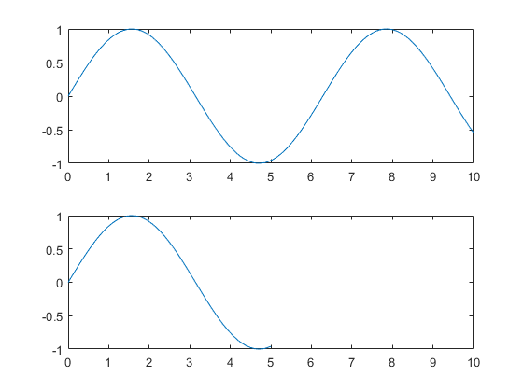

# image

Display image from array

## Syntax

* image(C)
* image(x,y,C)
* image('CData',C)
* image('XData',x,'YData',y,'CData',C)
* image(**\_\_\_**,Name,Value)
* image(ax,**\_\_\_**)
* im = image(**\_\_\_**)

## Description

* image([C](http://in.mathworks.com/help/matlab/ref/image.html#inputarg_C)) displays the data in array C as an image. Each element of C specifies the color for 1 pixel of the image. The resulting image is an m-by-n grid of pixels where m is the number of columns and n is the number of rows in C. The row and column indices of the elements determine the centers of the corresponding pixels.
* image([x](http://in.mathworks.com/help/matlab/ref/image.html" \l "inputarg_x),[y](http://in.mathworks.com/help/matlab/ref/image.html#inputarg_y),[C](http://in.mathworks.com/help/matlab/ref/image.html#inputarg_C)) specifies the image location. Use x and y to specify the locations of the corners corresponding to C(1,1) and C(m,n). To specify both corners, set x and y as two-element vectors. To specify the first corner and let image determine the other, set x and y as scalar values. The image is stretched and oriented as applicable.
* image ('CData',[C](http://in.mathworks.com/help/matlab/ref/image.html#inputarg_C)) adds the image to the current axes without replacing existing plots. This syntax is the low-level version of image(C). For more information, see [High-Level Versus Low-Level Version of Image](http://in.mathworks.com/help/matlab/ref/image.html#buryijq).
* image ('XData',[x](http://in.mathworks.com/help/matlab/ref/image.html#inputarg_x),'YData',[y](http://in.mathworks.com/help/matlab/ref/image.html#inputarg_y),'CData',[C](http://in.mathworks.com/help/matlab/ref/image.html#inputarg_C)) specifies the image location. This syntax is the low-level version of image(x,y,C).
* image (**\_\_\_**,[Name,Value](http://in.mathworks.com/help/matlab/ref/image.html" \l "namevaluepairarguments)) specifies image properties using one or more name-value pair arguments. You can specify image properties with any of the input argument combinations in the previous syntaxes.
* image ([ax](http://in.mathworks.com/help/matlab/ref/image.html#inputarg_ax),**\_\_\_**) creates the image in the axes specified by ax instead of in the current axes (gca). The option ax can precede any of the input argument combinations in the previous syntaxes.
* im = image(**\_\_\_**) returns the image object created. Use im to set properties of the image after it is created. You can specify this output with any of the input argument combinations in the previous syntaxes. For a list of image properties and descriptions, see [Image Properties](http://in.mathworks.com/help/matlab/ref/image-properties.html).

## Examples

Create matrix C. Display an image of the data in C. Add a colorbar to the graph to show the current colormap.

C = [0 2 4 6; 8 10 12 14; 16 18 20 22];

image(C)

colorbar

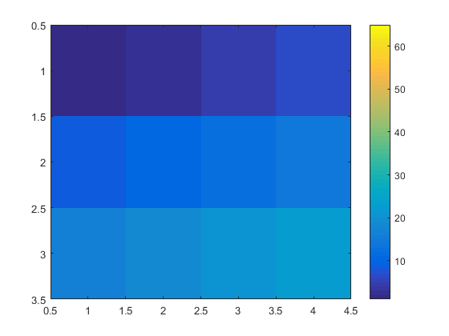

# imagesc

Display image with scaled colors

## Syntax

* imagesc(C)
* imagesc(x,y,C)
* imagesc(**\_\_\_**,clims)
* imagesc('CData',C)
* imagesc('XData',x,'YData',y,'CData',C)
* imagesc(**\_\_\_**,Name,Value)
* imagesc(ax,**\_\_\_**)
* im = imagesc(**\_\_\_**)

## Description

* imagesc([C](http://in.mathworks.com/help/matlab/ref/imagesc.html#inputarg_C)) displays the data in array C as an image that uses the full range of colors in the colormap. Each element of C specifies the color for 1 pixel of the image. The resulting image is an m-by-n grid of pixels where m is the number of columns and n is the number of rows in C. The row and column indices of the elements determine the centers of the corresponding pixels.
* imagesc([x](http://in.mathworks.com/help/matlab/ref/imagesc.html" \l "inputarg_x),[y](http://in.mathworks.com/help/matlab/ref/imagesc.html#inputarg_y),[C](http://in.mathworks.com/help/matlab/ref/imagesc.html#inputarg_C)) specifies the image location. Use x and y to specify the locations of the corners corresponding to C(1,1) and C(m,n). To specify both corners, set x and y as two-element vectors. To specify the first corner and let imagesc determine the other, set x and y as scalar values. The image is stretched and oriented as applicable.
* imagesc(**\_\_\_**,[clims](http://in.mathworks.com/help/matlab/ref/imagesc.html" \l "inputarg_clims)) specifies the data values that map to the first and last elements of the colormap. Specify clims as a two-element vector of the form [cmin cmax], where values less than or equal to cmin map to the first color in the colormap and values greater than or equal to cmax map to the last color in the colormap.
* imagesc('CData',[C](http://in.mathworks.com/help/matlab/ref/imagesc.html#inputarg_C)) adds the image to the current axes without replacing existing plots. This syntax is the low-level version of imagesc(C). For more information, see [High-Level Versus Low-Level Version](http://in.mathworks.com/help/matlab/ref/imagesc.html#bux1nfb-2).
* imagesc('XData',[x](http://in.mathworks.com/help/matlab/ref/imagesc.html#inputarg_x),'YData',[y](http://in.mathworks.com/help/matlab/ref/imagesc.html#inputarg_y),'CData',[C](http://in.mathworks.com/help/matlab/ref/imagesc.html#inputarg_C)) specifies the image location. This syntax is the low-level version of imagesc(x,y,C).
* imagesc(**\_\_\_**,[Name,Value](http://in.mathworks.com/help/matlab/ref/imagesc.html" \l "namevaluepairarguments)) specifies image properties using one or more name-value pair arguments. You can specify image properties with any of the input argument combinations in the previous syntaxes. For a list of image properties and descriptions, see [Image Properties](http://in.mathworks.com/help/matlab/ref/image-properties.html).
* imagesc([ax](http://in.mathworks.com/help/matlab/ref/imagesc.html" \l "inputarg_ax),**\_\_\_**) creates the image in the axes specified by ax instead of in the current axes (gca). The option ax can precede any of the input argument combinations in the previous syntaxes.
* [im](http://in.mathworks.com/help/matlab/ref/imagesc.html#outputarg_im) = imagesc(**\_\_\_**) returns the image object created. Use im to set properties of the image after it is created. You can specify this output with any of the input argument combinations in the previous syntaxes.

## Examples

Create matrix C. Display an image of the data in C. Add a colorbar to the graph to show the current colormap. By default, imagesc scales the color limits so that image uses the full range of the colormap, where the smallest value in C maps to the first color in the colormap and the largest value maps to the last color.

C = [0 2 4 6; 8 10 12 14; 16 18 20 22];

imagesc(C)

colorbar

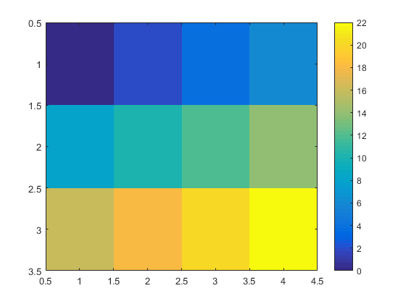

# imread

Read image from graphics file

## Syntax

* A = imread(filename)
* A = imread(filename,fmt)
* A = imread(**\_\_\_**,idx)
* A = imread(**\_\_\_**,Name,Value)
* [A,map] = imread(**\_\_\_**)
* [A,map,transparency] = imread(**\_\_\_**)

## Description

* [A](http://in.mathworks.com/help/matlab/ref/imread.html#outputarg_A) = imread([filename](http://in.mathworks.com/help/matlab/ref/imread.html" \l "inputarg_filename)) reads the image from the file specified by filename, inferring the format of the file from its contents. If filename is a multi-image file, then imread reads the first image in the file.
* [A](http://in.mathworks.com/help/matlab/ref/imread.html#outputarg_A) = imread([filename](http://in.mathworks.com/help/matlab/ref/imread.html" \l "inputarg_filename),[fmt](http://in.mathworks.com/help/matlab/ref/imread.html#inputarg_fmt)) additionally specifies the format of the file with the standard file extension indicated by fmt. If imread cannot find a file with the name specified by filename, it looks for a file named *filename.fmt*.
* [A](http://in.mathworks.com/help/matlab/ref/imread.html#outputarg_A) = imread(**\_\_\_**,[idx](http://in.mathworks.com/help/matlab/ref/imread.html" \l "inputarg_idx)) reads the specified image or images from a multi-image file. This syntax applies only to GIF, CUR, ICO, and HDF4 files. You must specify a [filename](http://in.mathworks.com/help/matlab/ref/imread.html#inputarg_filename) input, and you can optionally specify [fmt](http://in.mathworks.com/help/matlab/ref/imread.html" \l "inputarg_fmt).
* [A](http://in.mathworks.com/help/matlab/ref/imread.html#outputarg_A) = imread(**\_\_\_**,[Name,Value](http://in.mathworks.com/help/matlab/ref/imread.html" \l "namevaluepairarguments)) specifies format-specific options using one or more name-value pair arguments, in addition to any of the input arguments in the previous syntaxes.
* [[A](http://in.mathworks.com/help/matlab/ref/imread.html" \l "outputarg_A),[map](http://in.mathworks.com/help/matlab/ref/imread.html#outputarg_map)] = imread(**\_\_\_**) reads the indexed image in filename into A and reads its associated colormap into map. Colormap values in the image file are automatically rescaled into the range [0,1].
* [[A](http://in.mathworks.com/help/matlab/ref/imread.html" \l "outputarg_A),[map](http://in.mathworks.com/help/matlab/ref/imread.html#outputarg_map),[transparency](http://in.mathworks.com/help/matlab/ref/imread.html#outputarg_transparency)] = imread(**\_\_\_**) additionally returns the image transparency. This syntax applies only to PNG, CUR, and ICO files. For PNG files, transparency is the alpha channel, if one is present. For CUR and ICO files, it is the AND (opacity) mask.

## Examples

A = imread('ngc6543a.jpg');

# imwrite

Write image to graphics file

## Syntax

* imwrite(A,filename)
* imwrite(A,map,filename)
* imwrite(**\_\_\_**,fmt)
* imwrite(**\_\_\_**,Name,Value)

## Description

imwrite([A](http://in.mathworks.com/help/matlab/ref/imwrite.html" \l "inputarg_A),[filename](http://in.mathworks.com/help/matlab/ref/imwrite.html#inputarg_filename)) writes image data A to the file specified by filename, inferring the file format from the extension. imwrite creates the new file in your current folder. The bit depth of the output image depends on the data type of A and the file format. For most formats:

* If A is of data type uint8, then imwrite outputs 8-bit values.
* If A is of data type uint16 and the output file format supports 16-bit data (JPEG, PNG, and TIFF), then imwrite outputs 16-bit values. If the output file format does not support 16-bit data, then imwrite returns an error.
* If A is a grayscale or RGB color image of data type double or single, then imwrite assumes that the dynamic range is [0,1] and automatically scales the data by 255 before writing it to the file as 8-bit values. If the data in A is single, convert A to double before writing to a GIF or TIFF file.
* If A is of data type logical, then imwrite assumes that the data is a binary image and writes it to the file with a bit depth of 1, if the format allows it. BMP, PNG, or TIFF formats accept binary images as input arrays.

If A contains indexed image data, you should additionally specify the map input argument.

imwrite([A](http://in.mathworks.com/help/matlab/ref/imwrite.html" \l "inputarg_A),[map](http://in.mathworks.com/help/matlab/ref/imwrite.html#inputarg_map),[filename](http://in.mathworks.com/help/matlab/ref/imwrite.html#inputarg_filename)) writes the indexed image in A and its associated colormap, map, to the file specified by filename.

* If A is an indexed image of data type double or single, then imwrite converts the indices to zero-based indices by subtracting 1 from each element, and then writes the data as uint8. If the data in A is single, convert A to double before writing to a GIF or TIFF file.

imwrite(**\_\_\_**,[fmt](http://in.mathworks.com/help/matlab/ref/imwrite.html" \l "inputarg_fmt)) writes the image in the format specified by fmt, regardless of the file extension in filename. You can specify fmt after the input arguments in any of the previous syntaxes.

imwrite(**\_\_\_**,[Name,Value](http://in.mathworks.com/help/matlab/ref/imwrite.html" \l "namevaluepairarguments)) specifies additional parameters for output GIF, HDF, JPEG, PBM, PGM, PNG, PPM, and TIFF files, using one or more name-value pair arguments. You can specify Name,Value after the input arguments in any of the previous syntaxes.

## Examples

A = rand(50);

imwrite(A,'myGray.png')

# imfinfo

Information about graphics file

## Syntax

* info = imfinfo(filename)
* info = imfinfo(filename,fmt)
* info = imfinfo(URL)

## Description

* [info](http://in.mathworks.com/help/matlab/ref/imfinfo.html#outputarg_info) = imfinfo([filename](http://in.mathworks.com/help/matlab/ref/imfinfo.html#inputarg_filename)) returns a structure whose fields contain information about an image in a graphics file, filename.
* The format of the file is inferred from its contents.
* If filename is a TIFF, HDF, ICO, GIF, or CUR file containing more than one image, then info is a structure array with one element for each image in the file. For example, info(3) would contain information about the third image in the file.
* [info](http://in.mathworks.com/help/matlab/ref/imfinfo.html#outputarg_info) = imfinfo([filename](http://in.mathworks.com/help/matlab/ref/imfinfo.html" \l "inputarg_filename),[fmt](http://in.mathworks.com/help/matlab/ref/imfinfo.html#inputarg_fmt)) additionally looks for a file named filename.fmt, if MATLAB® cannot find a file named filename.
* [info](http://in.mathworks.com/help/matlab/ref/imfinfo.html#outputarg_info) = imfinfo([URL](http://in.mathworks.com/help/matlab/ref/imfinfo.html#inputarg_URL)) returns information about the image at the specified internet resource, URL.

## Examples

info = imfinfo('ngc6543a.jpg');

# ind2rgb

Convert indexed image to RGB image

## Syntax

RGB = ind2rgb(X,map)

## Description

RGB = ind2rgb(X,map) converts the indexed image, X, and the corresponding colormap, map, to the truecolor image, RGB. The indexed image, X, is an m-by-n array of integers. The colormap, map, is a three-column array of values in the range [0,1]. Each row of map is a three-element RGB triplet that specifies the red, green, and blue components of a single color of the colormap.

* If you specify X as an array of class uint8 or uint16, then the value 0 corresponds to the first color in the colormap.
* If you specify X as an array of class single or double, then the value 1 corresponds to the first color in the colormap.

The truecolor image output, RGB, is an m-by-n-by-3 array. For more information on image types, see [Image Types](http://in.mathworks.com/help/matlab/creating_plots/image-types.html).

**Image Operations**

**• Classification of Image Operations**

**-** Spatial domain methods

\* Point Processing Tranformations

\* Area/Mask Processing Tranformations

\* Geometric Tranformations

\* Frame Processing Transformations

- Frequency domain methods

**Point Processing Methods**

- The most primitive, yet essential, image processing operations.

- Intensity transformations that convert an old pixel into a new pixel based on some

Pre-defined function

- They operate on a pixel based solely on that pixel’s value.

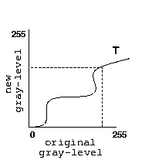- Used primarily for *contrast enhancement.*

**• Identity Transformation**

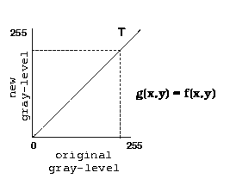

**• Negative Transformation**

O(r, c) = 255 − I (r, c)

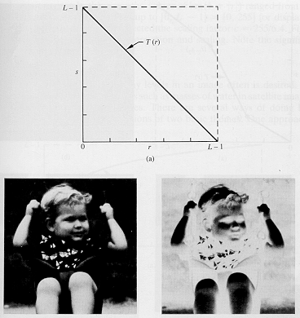

**• Contrast Stretching/Compression**

- Stretch gray-level ranges where we desire more information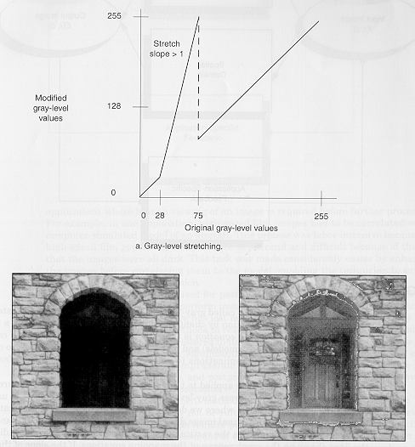

**• Intensity-Level Slicing**

- Highlight a specific range of gray-levels only.

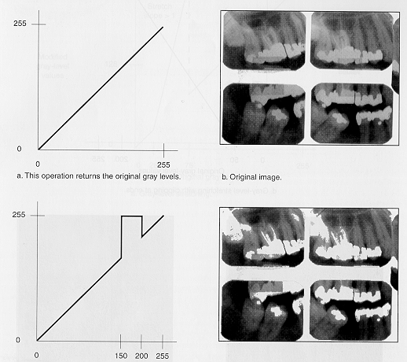

(same as double-thresholding)

**• Non-linear Transformations**

- We may use any function, provided that is gives a one-to-one or many-to-one (i.e.,

single-valued) mapping.

Logarithmic

- Useful for enhancing details in the darker regions of the image at the expense of detail in the brighter regions.

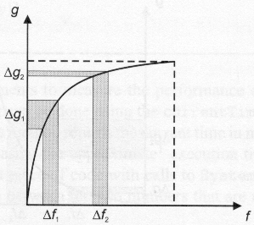

**Exponential**

- The effect is the reverse of that obtained with logarithmic mapping.

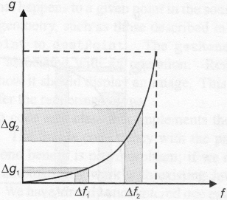

**• Thresholding**

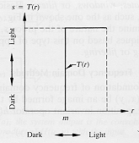

**• Histogram Equalization**

- Low contrast images are usually mostly dark, mostly light, or mostly gray.

- High contrast images have large regions of dark and large regions of white (e.g.,

someone inside a room, stading in front of a window on a sunny day).

- Good contrast images exhibit a wide range of pixel values (i.e., no single gray level

dominates the image).

- The histogram of an image (i.e., a plot of the gray-level frequences) provides impor-

tant information regarding the contrast of an image.

\* Histogram with a small spread: low contrast image

\* Histogram with wide spread: high contrast image

\* Histogram clustered at the low end: dark image

\* Histogram clustered at the high end: bright image

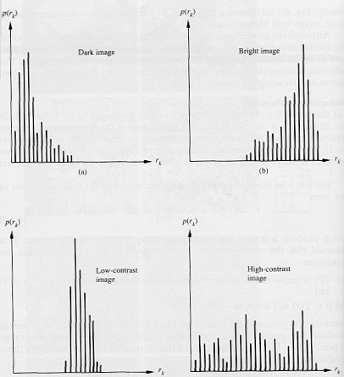

- Histogram equalization is a tranformation that stretches the contrast by redistribut-

ing the gray-level values uniformly.

- It is fully automatic compared to other contrast stretching techniques.

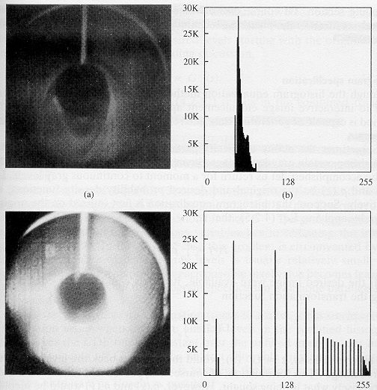

# MILESTONE 2

# Image Acquisition

The first stage of any vision system is the image acquisition stage.

After the image has been obtained, various methods of processing can be applied to the image to perform the many different vision tasks required today.

However, if the image has not been acquired satisfactorily then the intended tasks may not be achievable, **even** with the aid of some form of image enhancement

* [2D Image Input](https://users.cs.cf.ac.uk/Dave.Marshall/Vision_lecture/node5.html#SECTION00131000000000000000)

The basic two-dimensional image is a monochrome (greyscale) image which has been digitised.

Describe image as a two-dimensional light intensity function *f*(*x*,*y*) where *x* and *y* are spatial coordinates and the value of *f* at any point (*x*, *y*) is proportional to the brightness or grey value of the image at that point.

A digitised image is one where

* spatial and greyscale values have been made discrete.
* intensity measured across a regularly spaced grid in *x* and *y* directions
* intensities sampled to 8 bits (256 values).

For computational purposes, we may think of a digital image as a two-dimensional array where *x* and *y* index an image point. Each element in the array is called a pixel (picture element).

**Greyscale image and highlighted region**

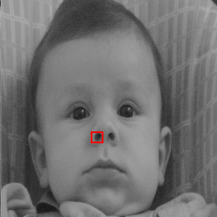

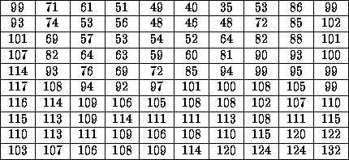

**Pixel values in highlighted region**

### 2D Input Devices

***TV Camera or Videocon Tube***

*A first choice for a two-dimensional image input device may be a television camera -- output is a video signal:*

* Image focused onto a photoconductive target.
* Target scanned line by line horizontally by an electron beam
* Electric current produces as the beam passes over target.
* Current proportional to the intensity of light at each point.
* Tap current to give a video signal.

*This form of device has several disadvantages.*

Limited resolution

-- finite number of scan lines (about 625) and frame rate (30 or 60 frames per second)

Distortion

* unwanted persistence between one frame and the next
* Non-linear video output with respect to light intensity.
* Non-flat target on tube.

***CCD Camera***

*By far the most popular two-dimensional imaging device is the charge-coupled device (CCD) camera.*

* Single IC device
* Consists of an array of photosensitive cells
* each cell produces an electric current dependent on the incident light falling on it.
* Video Signal Output
* Less geometric distortion
* More linear Video output.

### 

### Frame Stores

Video Signal must be digitised.

A device known as a frame storeor frame grabber usually performs this task. It:

* Digitises the incoming video signal
* Samples signal into discrete pixels at appropriate intervals -- line by line.
* Samples signal into a (8 bit) digital value.
* Stores sample frame own memory.
* Frame easily transferred to computer memory or a file.

**Image Enhancement**

Contrast adjustment, morphological filtering, de-blurring, and other image enhancement tools

Image enhancement techniques bring out the detail in an image that is obscured or highlight certain features of interest in an image. Enhancement techniques include contrast adjustment, filtering, morphological filtering, and de-blurring. Image enhancement operations typically return a modified version of the original image and are frequently used as a pre-processing step to improve the results of image analysis techniques.

* [**Contrast Adjustment**](https://in.mathworks.com/help/images/contrast-adjustment-.html)  
  Contrast adjustment, histogram equalization, de-correlation stretching

## Functions

|  |  |
| --- | --- |
| [imadjust](https://in.mathworks.com/help/images/ref/imadjust.html) | Adjust image intensity values or colormap |
| [imcontrast](https://in.mathworks.com/help/images/ref/imcontrast.html) | Adjust Contrast tool |
| [imsharpen](https://in.mathworks.com/help/images/ref/imsharpen.html) | Sharpen image using unsharp masking |
| [locallapfilt](https://in.mathworks.com/help/images/ref/locallapfilt.html) | Fast Local Laplacian Filtering of images |
| [localcontrast](https://in.mathworks.com/help/images/ref/localcontrast.html) | Edge-aware local contrast manipulation of images |
| [localtonemap](https://in.mathworks.com/help/images/ref/localtonemap.html) | Render HDR image for viewing while enhancing local contrast |
| [histeq](https://in.mathworks.com/help/images/ref/histeq.html) | Enhance contrast using histogram equalization |
| [adapthisteq](https://in.mathworks.com/help/images/ref/adapthisteq.html) | Contrast-limited adaptive histogram equalization (CLAHE) |
| [imhistmatch](https://in.mathworks.com/help/images/ref/imhistmatch.html) | Adjust histogram of image to match N-bin histogram of reference image |
| [decorrstretch](https://in.mathworks.com/help/images/ref/decorrstretch.html) | Apply de-correlation stretch to multichannel image |
| [stretchlim](https://in.mathworks.com/help/images/ref/stretchlim.html) | Find limits to contrast stretch image |
| [intlut](https://in.mathworks.com/help/images/ref/intlut.html) | Convert integer values using lookup table |
| [imnoise](https://in.mathworks.com/help/images/ref/imnoise.html) | Add noise to image |

# Image Filtering

Convolution and correlation, predefined and custom filters, nonlinear filtering, edge-preserving filters

## Functions

|  |  |
| --- | --- |
| [imfilter](https://in.mathworks.com/help/images/ref/imfilter.html) | N-D filtering of multidimensional images |
| [imgaussfilt](https://in.mathworks.com/help/images/ref/imgaussfilt.html) | 2-D Gaussian filtering of images |
| [imgaussfilt3](https://in.mathworks.com/help/images/ref/imgaussfilt3.html) | 3-D Gaussian filtering of 3-D images |
| [fspecial](https://in.mathworks.com/help/images/ref/fspecial.html) | Create predefined 2-D filter |
| [imguidedfilter](https://in.mathworks.com/help/images/ref/imguidedfilter.html) | Guided filtering of images |
| [normxcorr2](https://in.mathworks.com/help/images/ref/normxcorr2.html) | Normalized 2-D cross-correlation |
| [wiener2](https://in.mathworks.com/help/images/ref/wiener2.html) | 2-D adaptive noise-removal filtering |
| [medfilt2](https://in.mathworks.com/help/images/ref/medfilt2.html) | 2-D median filtering |
| [medfilt3](https://in.mathworks.com/help/images/ref/medfilt3.html) | 3-D median filtering |
| [ordfilt2](https://in.mathworks.com/help/images/ref/ordfilt2.html) | 2-D order-statistic filtering |
| [stdfilt](https://in.mathworks.com/help/images/ref/stdfilt.html) | Local standard deviation of image |
| [rangefilt](https://in.mathworks.com/help/images/ref/rangefilt.html) | Local range of image |
| [entropyfilt](https://in.mathworks.com/help/images/ref/entropyfilt.html) | Local entropy of grayscale image |
| [nlfilter](https://in.mathworks.com/help/images/ref/nlfilter.html) | General sliding-neighborhood operations |

|  |  |
| --- | --- |
| [gabor](https://in.mathworks.com/help/images/ref/gabor.html) | Create Gabor filter or Gabor filter bank |
| [imgaborfilt](https://in.mathworks.com/help/images/ref/imgaborfilt.html) | Apply Gabor filter or set of filters to 2-D image |
| [imboxfilt](https://in.mathworks.com/help/images/ref/imboxfilt.html) | 2-D box filtering of images |
| [imboxfilt3](https://in.mathworks.com/help/images/ref/imboxfilt3.html) | 3-D box filtering of 3-D images |
| [integralImage](https://in.mathworks.com/help/images/ref/integralimage.html) | Calculate integral image |
| [integralImage3](https://in.mathworks.com/help/images/ref/integralimage3.html) | Calculate 3-D integral image |
| [integralBoxFilter](https://in.mathworks.com/help/images/ref/integralboxfilter.html) | 2-D box filtering of integral images |
| [integralBoxFilter3](https://in.mathworks.com/help/images/ref/integralboxfilter3.html) | 3-D box filtering of 3-D integral images |

|  |  |
| --- | --- |
| [bwareafilt](https://in.mathworks.com/help/images/ref/bwareafilt.html) | Extract objects from binary image by size |
| [bwpropfilt](https://in.mathworks.com/help/images/ref/bwpropfilt.html) | Extract objects from binary image using properties |
| [padarray](https://in.mathworks.com/help/images/ref/padarray.html) | Pad array |
| [freqz2](https://in.mathworks.com/help/images/ref/freqz2.html) | 2-D frequency response |
| [fsamp2](https://in.mathworks.com/help/images/ref/fsamp2.html) | 2-D FIR filter using frequency sampling |
| [ftrans2](https://in.mathworks.com/help/images/ref/ftrans2.html) | 2-D FIR filter using frequency transformation |
| [fwind1](https://in.mathworks.com/help/images/ref/fwind1.html) | 2-D FIR filter using 1-D window method |
| [fwind2](https://in.mathworks.com/help/images/ref/fwind2.html) | 2-D FIR filter using 2-D window method |
| [convmtx2](https://in.mathworks.com/help/images/ref/convmtx2.html) | 2-D convolution matrix |

# Morphological Operations

Dilate, erode, reconstruct, and perform other morphological operations

## Functions

|  |  |
| --- | --- |
| [bwhitmiss](https://in.mathworks.com/help/images/ref/bwhitmiss.html) | Binary hit-miss operation |
| [bwmorph](https://in.mathworks.com/help/images/ref/bwmorph.html) | Morphological operations on binary images |
| [bwulterode](https://in.mathworks.com/help/images/ref/bwulterode.html) | Ultimate erosion |
| [bwareaopen](https://in.mathworks.com/help/images/ref/bwareaopen.html) | Remove small objects from binary image |
| [imbothat](https://in.mathworks.com/help/images/ref/imbothat.html) | Bottom-hat filtering |
| [imclearborder](https://in.mathworks.com/help/images/ref/imclearborder.html) | Suppress light structures connected to image border |
| [imclose](https://in.mathworks.com/help/images/ref/imclose.html) | Morphologically close image |
| [imdilate](https://in.mathworks.com/help/images/ref/imdilate.html) | Dilate image |
| [imerode](https://in.mathworks.com/help/images/ref/imerode.html) | Erode image |
| [imextendedmax](https://in.mathworks.com/help/images/ref/imextendedmax.html) | Extended-maxima transform |
| [imextendedmin](https://in.mathworks.com/help/images/ref/imextendedmin.html) | Extended-minima transform |
| [imfill](https://in.mathworks.com/help/images/ref/imfill.html) | Fill image regions and holes |
| [imhmax](https://in.mathworks.com/help/images/ref/imhmax.html) | H-maxima transform |
| [imhmin](https://in.mathworks.com/help/images/ref/imhmin.html) | H-minima transform |
| [imimposemin](https://in.mathworks.com/help/images/ref/imimposemin.html) | Impose minima |
| [imopen](https://in.mathworks.com/help/images/ref/imopen.html) | Morphologically open image |
| [imreconstruct](https://in.mathworks.com/help/images/ref/imreconstruct.html) | Morphological reconstruction |
| [imregionalmax](https://in.mathworks.com/help/images/ref/imregionalmax.html) | Regional maxima |
| [imregionalmin](https://in.mathworks.com/help/images/ref/imregionalmin.html) | Regional minima |
| [imtophat](https://in.mathworks.com/help/images/ref/imtophat.html) | Top-hat filtering |
| [watershed](https://in.mathworks.com/help/images/ref/watershed.html) | Watershed transform |
| [conndef](https://in.mathworks.com/help/images/ref/conndef.html) | Create connectivity array |
| [iptcheckconn](https://in.mathworks.com/help/images/ref/iptcheckconn.html) | Check validity of connectivity argument |

|  |  |
| --- | --- |
| [applylut](https://in.mathworks.com/help/images/ref/applylut.html) | Neighbourhood operations on binary images using lookup tables |
| [bwlookup](https://in.mathworks.com/help/images/ref/bwlookup.html) | Nonlinear filtering using lookup tables |
| [makelut](https://in.mathworks.com/help/images/ref/makelut.html) | Create lookup table for use with bwlookup |

## Classes

|  |  |
| --- | --- |
| [strel](https://in.mathworks.com/help/images/ref/strel-class.html) | Morphological structuring element |
| [offsetstrel](https://in.mathworks.com/help/images/ref/offsetstrel-class.html) | Morphological offset structuring elemenlookt |

# De-blurring

De-convolution for de-blurring

## Functions

|  |  |
| --- | --- |
| [deconvblind](https://in.mathworks.com/help/images/ref/deconvblind.html) | Deblur image using blind deconvolution |
| [deconvlucy](https://in.mathworks.com/help/images/ref/deconvlucy.html) | Deblur image using Lucy-Richardson method |
| [deconvreg](https://in.mathworks.com/help/images/ref/deconvreg.html) | Deblur image using regularized filter |
| [deconvwnr](https://in.mathworks.com/help/images/ref/deconvwnr.html) | Deblur image using Wiener filter |
| [edgetaper](https://in.mathworks.com/help/images/ref/edgetaper.html) | Taper discontinuities along image edges |
| [otf2psf](https://in.mathworks.com/help/images/ref/otf2psf.html) | Convert optical transfer function to point-spread function |
| [psf2otf](https://in.mathworks.com/help/images/ref/psf2otf.html) | Convert point-spread function to optical transfer function |

|  |  |
| --- | --- |
| [padarray](https://in.mathworks.com/help/images/ref/padarray.html) | Pad array |

# ROI-Based Processing

Define and operate on regions of interest (ROI)

## Functions

|  |  |
| --- | --- |
| [roipoly](https://in.mathworks.com/help/images/ref/roipoly.html) | Specify polygonal region of interest (ROI) |
| [poly2mask](https://in.mathworks.com/help/images/ref/poly2mask.html) | Convert region of interest (ROI) polygon to region mask |
| [regionfill](https://in.mathworks.com/help/images/ref/regionfill.html) | Fill in specified regions in image using inward interpolation |
| [roicolor](https://in.mathworks.com/help/images/ref/roicolor.html) | Select region of interest (ROI) based on color |
| [roifilt2](https://in.mathworks.com/help/images/ref/roifilt2.html) | Filter region of interest (ROI) in image |
| [imellipse](https://in.mathworks.com/help/images/ref/imellipse.html) | Create draggable ellipse |
| [imfreehand](https://in.mathworks.com/help/images/ref/imfreehand.html) | Create draggable freehand region |
| [impoly](https://in.mathworks.com/help/images/ref/impoly.html) | Create draggable, resizable polygon |
| [imrect](https://in.mathworks.com/help/images/ref/imrect.html) | Create draggable rectangle |
| [imroi](https://in.mathworks.com/help/images/ref/imroi.html) | Region-of-interest (ROI) base class |

# Neighborhood and Block Processing

Define neighborhoods and blocks for filtering and I/O operations

## Classes

|  |  |
| --- | --- |
| [ImageAdapter](https://in.mathworks.com/help/images/ref/imageadapter-class.html) | Interface for image I/O |

## Functions

|  |  |
| --- | --- |
| [blockproc](https://in.mathworks.com/help/images/ref/blockproc.html) | Distinct block processing for image |
| [bestblk](https://in.mathworks.com/help/images/ref/bestblk.html) | Determine optimal block size for block processing |
| [nlfilter](https://in.mathworks.com/help/images/ref/nlfilter.html) | General sliding-neighborhood operations |
| [col2im](https://in.mathworks.com/help/images/ref/col2im.html) | Rearrange matrix columns into blocks |
| [colfilt](https://in.mathworks.com/help/images/ref/colfilt.html) | Columnwise neighborhood operations |
| [im2col](https://in.mathworks.com/help/images/ref/im2col.html) | Rearrange image blocks into columns |

# Image Arithmetic

Add, subtract, multiply, and divide images

## Functions

|  |  |
| --- | --- |
| [imabsdiff](https://in.mathworks.com/help/images/ref/imabsdiff.html) | Absolute difference of two images |
| [imadd](https://in.mathworks.com/help/images/ref/imadd.html) | Add two images or add constant to image |
| [imapplymatrix](https://in.mathworks.com/help/images/ref/imapplymatrix.html) | Linear combination of color channels |
| [imcomplement](https://in.mathworks.com/help/images/ref/imcomplement.html) | Complement image |
| [imdivide](https://in.mathworks.com/help/images/ref/imdivide.html) | Divide one image into another or divide image by constant |
| [imlincomb](https://in.mathworks.com/help/images/ref/imlincomb.html) | Linear combination of images |
| [immultiply](https://in.mathworks.com/help/images/ref/immultiply.html) | Multiply two images or multiply image by constant |
| [imsubtract](https://in.mathworks.com/help/images/ref/imsubtract.html) | Subtract one image from another or subtract constant from image |

**Image De noising**

**Noise**

Image noise is random variation of brightness or colour information in images, and is usually an aspect of electronic noise. It can be produced by the sensor and circuitry of a scanner or digital camera.

**De-noising** is any signal processing method which reconstructs a signal from a noisy one. Its goal is to remove noise and preserve useful information. Learn more in: Enhancement of Recorded Respiratory Sound Using Signal Processing Techniques.

**Image de-noising** is an important image processing task, both as a process itself, and as a component in other processes. Very many ways to de-noise an image or a set of data exists. The main properties of a good image de-noising model are that it will remove noise while preserving edges.

**Types of noise:**

**1. Gaussian Noise or Amplifier Noise:**

It is also known as Gaussian distribution. It has a probability density function (PDF) of the normal distribution. This noise is added to image during image acquisition like sensor noise caused by low light, high temperature, transmission e.g. electronic circuit noise [7]. This noise can be removed by using spatial filtering (mean filtering, median filtering and Gaussian smoothing) by smoothing the image but smoothing also blurs the fine-scaled image edges and details. [4]. The PDF of Gaussian Noise is shown in the following equation and figure:

(𝑧)=1√2𝜋𝜎𝑒− (𝑧−𝜇) ^2/2𝜎2



**PDF of Gaussian Noise**

** **

**Image containing Gaussian Noise**

**2. Impulse Noise:**

The Impulse noise is also known as Salt & Pepper noise or Spike noise. It is caused by malfunctioning pixels in camera sensors, faulty memory locations in hardware, or transmission in a noisy channel [1]. It is always Independent and uncorrelated to image pixels. Its two types are the salt-and-pepper noise and the random-valued noise. In salt and pepper type of noise, the noisy pixels takes either salt value (gray level -225) or pepper value (grey level -0) and it appears as black and white spots on the images In case of random valued impulse noise, noise can take any gray level value from zero to 225. In this case also noise is randomly distributed over the entire image and probability of occurrence of any gray level value as noise will be same [5].

**Reasons for Salt and Pepper Noise*:***

1) Due to failure of memory cells or wrong working of sensor cells of camera.

2) Due to synchronization errors while transmitting image over media [18].

The PDF of Impulse noise is shown in following equation and figure:

P (z) = {𝑝𝑎𝑓𝑜𝑟 𝑧=𝑎

𝑝𝑏 𝑓𝑜𝑟 𝑧=𝑏

0 𝑜𝑡ℎ𝑒𝑟𝑤𝑖𝑠𝑒



**PDF of Impulse (Salt & pepper) Noise**



**Image containing Impulse Noise**

**3. Speckle Noise:**

Speckle noise is a granular noise. This noise generally degrades Synthetic Aperture Radar (SAR) images to large extent. This noise is generally caused due to random ups and downs in the signal coming back from an object that is smaller than a single image-processing element. It is also caused by consistent processing of backscattered signals from a no of distributed targets. This noise also increases the mean grey level of affecting image. This noise creates a lot of difficulty in interpreting the image. [20].



**Image Containing Speckle Noise**

**4. Poisson Noise:**

Poisson noise is also known as Photon noise. It arises when number of photons sensed by the sensor is not sufficient to provide detectable statistical information [16]. This noise has root mean square value proportional to square root intensity of the image. Different pixels are suffered by independent noise values. The photon noise and other sensor based noise corrupt the signal at different proportions [15]. The PDF of Poisson Noise is shown in following equation and figure:

𝑝(𝑥)=𝑒^−𝜆𝜆^𝑥/ 𝑥! 𝑓𝑜𝑟 𝜆 > 0 and x=0,1,2 ...

****

**PDF of Poisson Noise**

****

**Image containing Poisson Noise**

**5. Uniform Noise:**

The Uniform noise caused by quantizing the pixels of image to a number of distinct levels is known as Quantization noise. It has approximately uniform distribution. In this type of noise, the level of the g-ray values of the noise is uniformly distributed over a specified range. It can be used to create any type of noise distribution. This type of noise is mostly used to evaluate the performance of image restoration algorithms. This noise provides the most neutral or unbiased noise [10]. The PDF, mean and variance of Uniform Noise is shown below:

(𝑧)={1/(𝑏−𝑎), 𝑖𝑓 𝑎 ≤ 𝑧 ≤𝑏

0, o t ℎ 𝑒𝑟𝑤𝑖𝑠𝑒

𝜇=(𝑎+𝑏)/2

𝜎2=(𝑏−𝑎)^2/12

****

**PDF of uniform noise**



**Uniform Noise present in an Image**

**6. Rayleigh Noise:**

Radar range and velocity images typically contain noise that can be modelled by the Rayleigh distribution [18]. The PDF, mean and variance of Rayleigh Noise is given below:

(𝑧)={2/𝑏(𝑧−𝑎)𝑒^−(𝑧−𝑎)^2/𝑏 𝑓𝑜𝑟 𝑧 ≥ 𝑎

1. 𝑓𝑜𝑟 𝑧<𝑎

𝜇 = 𝑎 + √𝜋𝑏/4

𝜎^2 = (4−𝜇)/4



**PDF of Rayleigh Noise**



**Image containing Rayleigh Noise**

**7. Gamma Noise:**

This type of noise can be obtained by the low-pass filtering of laser based images [18]. The PDF, mean and variance of Gamma Noise is given below:

(𝑥)={𝑎^𝑧𝑧^𝑏−1/(𝑏−1)! 𝑒^−𝑎𝑧, 𝑓𝑜 < 00, 𝑧 ≥ 0

𝜇=𝑏/𝑎

𝜎^2=𝑏/𝑎^2



**PDF of Gamma noise**



**Image containing Gamma Noise**

**IMAGE DENOISING TECHNIQUES :**

There are different Image de-noising techniques developed so far each having its own advantages and limitation. One should choose the technique according to the type and amount of noise present in the image. One should also consider the other factors like performance in de-noising the image, computational time, and computational cost.

De-noising can be done in various domains like Spatial Domain, Frequency Domain and Wavelet Domain. The Spatial domain method is discussed below.

**1. Spatial Domain**

Here filtering is used for image noise removal. Filtering is a technique in image processing which is used for different tasks like noise reduction, interpolation, and re-sampling. It is mostly used in all image processing systems. The choice of filter depends upon the type and amount of noise present in an image because different filters can remove different types of noise efficiently.

Spatial Domain has following types of filters:

*1.1 Linear Filters:*

Linear filters are used to remove certain type of noise. Here filtering is generally done by blurring the image. These filters blur the edges and destroy the fine details of an image. They have poor performance in removing signal dependent noise. Gaussian and Averaging filters are commonly used linear filters [8]. They are of following types:

*1.1.1 Gaussian Filter:*

Gaussian filter is a non-uniform low pass filter. Gaussian filter is used to blur images and remove noise and detail. It does not remove salt & pepper noise effectively [3].

*1.1.2 Average Filter:*

The output of average filter is simply the average of pixels contained in the neighbourhood of filter mask. It calculates the average of all intensities of the neighbourhood of the central pixel and replaces the pixel with that average value. It is mostly used in removing irrelevant details from an image. It has a limitation that it blurs the edges of the image [19].

*1.2 Non-Linear Filters:*

In recent years, a variety of non-linear filters such as median filter, min filter, max filter have been developed to overcome the shortcoming of linear filter. Non-linear filters exhibit better performance than linear filters [10]. They are discussed below:

*1.2.1 Mean Filter:*

It is one of the simplest filters among the existing spatial filters. It uses a filter window which is usually square. The filter window replaces the centre value in the window with the average mean of all the pixels values in the kernel or window.

*1.2.2 Median Filter:*

It is also known as order statistics filter. It is most popular and commonly used non-linear filter. It removes noise by smoothing the images. This filter also lowers the intensity variation between one and other pixels of an image. In this filter, the pixel value of image is replaced with the median value. The median value is calculated by first arranging all the pixel values in ascending order and then replaces the pixel being calculated with the middle pixel value. If the neighbouring pixel of image which is to be consider, contains and even no of pixels, then it replaces the pixel with average of two middle pixel values. The median filter gives best result when the impulse noise percentage is less than 0.1 It does not perform well in removing high density salt & pepper noise [19]. The mean filter can be represented by the following equation:

𝑓^ (𝑥, 𝑦) = 𝑚𝑒𝑑𝑖𝑎n {g (𝑠, 𝑡)} 𝑤ℎ𝑒𝑟𝑒 (𝑠, 𝑡) ∈ 𝑆𝑥𝑦 (14)

Here S x y corresponds to the set of coordinates in a rectangular sub image window which has centre at (x, y). The median filter calculates the median of the corrupted image g(x, y) under the area S x y. Here f^(x, y) represents the restored image.

*1.2.3 Min Filter:*

Min filter is also known as 0th percentile filter. It replaces the value of pixel by the minimum intensity level of the neighbourhood of that pixel. This filter finds darkest points in an image. It removes salt noise from an image containing salt and pepper noise due to its high intensity value [19]. The min filter can be represented by the following equation:

𝑓 ^ (𝑥, 𝑦) = 𝑚𝑖𝑛 {𝑔 (𝑠, 𝑡)} 𝑤ℎ𝑒𝑟𝑒 (𝑠, 𝑡) ∈ 𝑆𝑥𝑦 (15)

*1.2.4 Max Filter:*

Max filter is also known as 100th percentile filter. It replaces the value of pixel by the maximum intensity level of the neighbourhood of that pixel. This filter finds brightest points in an image. It removes pepper noise from an image containing salt and pepper noise due to its very low intensity value [19].

𝑓^(𝑥,𝑦)=𝑚𝑎𝑥{𝑔(𝑠,𝑡)} 𝑤ℎ𝑒𝑟𝑒 (𝑠,𝑡)∈𝑆𝑥𝑦 (16)

*1.3 Adaptive Filters:*

These filters work accordingly the statistical characteristics of image inside the filter region defined by the m x n rectangular window. They are more complex and give better performance than existing spatial filters. The most commonly used spatial filter is adaptive median filter which is discussed below:

*1.3.1 Adaptive Median Filter:*

It performs well on images containing high density salt & pepper noise. It preserves the details of an image while smoothing non impulse noise. It changes its windows size during its operation depending on the certain conditions [19]. It works in two stages. First it calculates the minimum, maximum and median values of sub image window of the corrupted image. In stage one , it checks whether the calculated median itself is a salt or pepper noise or not. If the median is salt or pepper noise, then it increase the size of sub image window and recalculates the minimum, maximum and median values otherwise it proceeds to stage two. In stage two, it checks whether the selected pixel is a salt or pepper noise or not. If it is salt or pepper noise, then it replaces the selected pixel with previously calculated median otherwise the pixel remains unchanged.

**IMPLEMENTATION AND RESULTS**

Experiments were carried out on various standard gray scale images of size 256 x 256 which are of jpeg format and are shown in Figure 18. Simulation is performed using mat lab R2013a software.





**Original Images used for simulation (a) Lena, (b) Barbara, (c) Boat, (d) Baboon**

The input images are corrupted by a simulated Gaussian white noise (mean=0, variance=0.01), Salt & Pepper noise (noise density= 0.05), Speckle noise (mean=0, variance=0.04), Poisson noise, Uniform noise (interval [0, 1]), Rayleigh noise (parameters 0, 1), Erlangen noise (parameters 2, 5). For de-noising process, various spatial linear filters which are Gaussian filter (3x3), average filter (3x3) and spatial nonlinear filters which are median filter (3x3), min filter (3x3), max filter (3x3) and adaptive filters which are adaptive median filter (3x3), have been used.

The Quantitative performance of the spatial filters is evaluated through Peak signal to noise ratio (PSNR). It can be defined by following eq.

𝑃𝑆𝑁𝑅=10log10 (2552𝑀𝑆𝐸)

𝑀𝑆𝐸= ΣΣ (𝑟𝑖𝑗−𝑥𝑖𝑗)×𝑁

Where *r* refers to Original image, *x* denotes the restored image, M x N is the size of processed image.

Table 1: in the Appendix a shows performance of various spatial filters in removing the different types of noise in Lena image, in terms of p S nr. Similarly Tables 2, 3 and 4 corresponds to Barbara, Boat and Baboon image respectively. Figure 16 shows the Lena image corrupted with different noise types and each noisy image filtered using different filters. Similarly Figure 17 18 and19 corresponds to Barbara, Boat and Baboon image respectively.



**Fig 16 Lena image containing various types of noise and filtered by using different spatial filters**



**Fig17 Barbara image containing various types of noise and filtered by different spatial filters.**



**Fig 18 Boat image containing various types of noise and filtered by different spatial filters**

 **Fig 19 Baboon image containing various types of noise and filtered by different spatial filters**

**Image Segmentation**

Image segmentation is the front-stage processing of image compression. In general, we hope that there are three advantages in image segmentation. The first is the speed. When segmenting an image, we do not want speed much time to do it. The second is good shape connectivity of its segmenting result. When segmenting an image, we do not want the result of segmenting shape to be fragmentary. If the result of segmenting shape is fragmentary, we need take many resources to record the boundaries of the over-segment results. It is not we want to get the results. The third is good shape matching. Consequently, it will be reliable.

Image segmentation can be classified three categories traditionally including Threshold Technique, Region-Based Image Segmentation, and Edge-Based Image Segmentation.

1. **Threshold Technique**

Thethreshold technique is simplest in segmenting methods. To set two thresholds on the histogram of the image, we can classify between the two thresholds in the histogram as the same region and classify the others as the second region.

**Multi-level thresholding through a statistical recursive algorithm**

Multilevel thresholding for image segmentation through a statistical recursive algorithm is proposed in [9]. The algorithm is used in segmenting an image into multi-level by using mean and variance. The method can be made use of dealing with coloured images or images of complex background, and then can do what bi-level doesn’t it.

Multi-level thresholding algorithm:

1. Repeat steps 2~6, *n*/2-1 times; where *n* is the number of thresholds.

2. Range ***R*** = [*a*, *b*]; initially set a = 0 and b = 255.

3. Find mean () and standard deviation () of all the pixels in ***R***.

4. Sub-ranges’ boundaries  and  are calculated as  and; where  and  are free parameters.

5. Pixels with intensity values in the interval [*a*,] and [, *b*] are assigned threshold values equal to the respective weighted means of their values.

6., .

7. Finally, repeat step 5 with  and with.

Using the algorithm can the compute the PSNR (peak signal to noise ratio). After applying the algorithm a few times, we can find the PSNR to be saturated. By the property, we can get the appropriate number of thresholds *n.*

1. **Region-base Image Segmentation**

**a)Data clustering**

Data clustering is one method of Region-Based image segmentation, and it is popularly used mathematics and statistics. We can use the centroids or prototypes to present the great numbers of cluster to achieve the two goals of reducing the computational time consuming and providing a better condition to compress it.

In general, data clustering can be classified two kinds of system including hierarchical clustering and partitional clustering. In the hierarchical clustering, we can change the numbers of cluster during the process. However, in the partitional clustering, we must decide the numbers of cluster before processing.

**1. Hierarchical clustering**

For the hierarchical clustering, it has an advantage of simple concept. It is roughly classified two kinds of algorithms including hierarchical agglomerative algorithm and hierarchical divisive algorithm.

Hierarchical agglomerative algorithm:

1. Let every single data point (pixel or image) in the whole image as a cluster.
2. Look for the shortest distance of two data pointin the whole image, and merge them to become a new cluster.
3. Repeat the step 1 and step 2 until the numbers of cluster attain our demand.

We can use many ways to define the distance here.

Hierarchical divisive algorithm:

1. Let the whole image as a cluster.
2. Look for the biggest diameter of the cluster groups.
3. If, split  out as a new clusterand see the rest data points of  as.
4. If, split  out as.
5. Back to step 2 and continue the algorithm until  and  is not changed anymore.

The diameter of a cluster  as the diameter is defined as.

The mean of distance between  and every single point in cluster 

Using the method of hierarchical clustering, the result is characteristic of strong correlation with the original image. Therefore, it will be reliable. Nevertheless, it has a fatal defect of computational time consuming, then it cannot be used for the large image.

**2. Partitional clustering**

In the partitional clustering, we must decide the numbers of cluster before processing. The K-means algorithm is most well-known in the partitional clustering.

K-means algorithm:

1. Decide the numbers of the cluster  and choose randomly  data points ( pixels or image) in the whole image as the  centroids in  clusters.
2. Find out nearest centroid of every single data point (pixel or image) and classify the data point into that cluster the centroid located. After doing step 2, all data points are classified in some cluster.
3. Calculate the centroid of every cluster.
4. Repeat step 2 and step 3 until it is not changed.

Using the K-means algorithm, it has an advantage of less computing time. In other words, the partitional clustering is faster than the hierarchical clustering. However, the different initial centroids will bring about the different results which mean the K-means algorithm has an initial problem. In order to solve the initial problem, we can choose to use one initial point or use the Particle Swarm Optimization (PSO).

**Region growing**

Region growing is simplest in region-base image segmentationmethods. The concept of region growing algorithm is check the neighbouring pixels of the initial seed points, then determine whether those neighbouring pixels are added to the seed points or not. Therefore, it is an iterative process.

Region growing algorithm:

1. Choose the seed points.
2. If the neighboring pixels of the initial seed points are satisfy the criteria such as threshold, they will be grown. The threshold can be intensity, gray level texture, and color…etc.

We use the criteria of the same pixel value in Fig, and then check the neighbouring pixels of the initial seed points. If their pixel values are identical with seed points, they can be added to the seed points. It is stop until there is no change in two successive iterations. We use 4-connected neighbourhood to grow the neighbouring pixels of the initial seed points here.

|  |  |  |  |  |
| --- | --- | --- | --- | --- |
| 1 | 1 | 9 | 9 | 9 |
| 1 | 1 | 9 | 9 | 9 |
| 5 | 1 | 1 | 9 | 9 |
| 5 | 5 | 5 | 3 | 9 |
| 3 | 3 | 3 | 3 | 3 |

|  |  |  |  |  |
| --- | --- | --- | --- | --- |
| 1 | 1 | 9 | 9 | 9 |
| 1 | 1 | 9 | 9 | 9 |
| 5 | 1 | 1 | 9 | 9 |
| 5 | 5 | 5 | 3 | 9 |
| 3 | 3 | 3 | 3 | 3 |

|  |  |  |  |  |
| --- | --- | --- | --- | --- |
| 1 | 1 | 9 | 9 | 9 |
| 1 | 1 | 9 | 9 | 9 |
| 5 | 1 | 1 | 9 | 9 |
| 5 | 5 | 5 | 3 | 9 |
| 3 | 3 | 3 | 3 | 3 |

(a) Original image (b) step 1 (c) step2

|  |  |  |  |  |
| --- | --- | --- | --- | --- |
| 1 | 1 | 9 | 9 | 9 |
| 1 | 1 | 9 | 9 | 9 |
| 5 | 1 | 1 | 9 | 9 |
| 5 | 5 | 5 | 3 | 9 |
| 3 | 3 | 3 | 3 | 3 |

|  |  |  |  |  |
| --- | --- | --- | --- | --- |
| 1 | 1 | 9 | 9 | 9 |
| 1 | 1 | 9 | 9 | 9 |
| 5 | 1 | 1 | 9 | 9 |
| 5 | 5 | 5 | 3 | 9 |
| 3 | 3 | 3 | 3 | 3 |

|  |  |  |  |  |
| --- | --- | --- | --- | --- |
| 1 | 1 | 9 | 9 | 9 |
| 1 | 1 | 9 | 9 | 9 |
| 5 | 1 | 1 | 9 | 9 |
| 5 | 5 | 5 | 3 | 9 |
| 3 | 3 | 3 | 3 | 3 |

(d) Step 3 (e) steps 4 (f) step5

Fig. An example of region growing

**Region merging and splitting**

Region merging and splitting is a developing algorithm in segmenting the images [4]. It is used to differentiate the homogeneity of the image.

Region merging and splittingalgorithm:

1. Splitting step:

We choose the criteria to split the image based on quad tree. At the same time, we can determine the numbers of splitting levels gradually.

1. Merging step:

If the adjacent regions satisfy the similarity properties, we will merge them.

1. Repeat step 2 until it is not changed.

In the below Fig., it is an example of region merging and splittingalgorithm. We use the splitting criteria and the merging criteria of the locating total area of one section. We split the image until get the resolution we need. In fig. (a), (b), (c) and (d) show the splitting part and Fig. (e) and (f) show the merging part.

splt_merge_robot3splt_merge_robot2splt_merge_robot1

(a) Original Image (b) Splitting: stage 1 (c) Splitting: stage 4

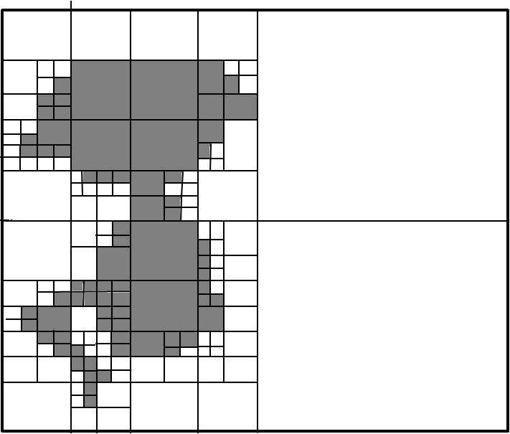splt_merge_robot4splt_merge_robot4

(d) Splitting: stage 5 (e) Merging: stage 5 (f) Merging result

Fig. The example of region merging and splitting.

The quad tree-based segmentation has the problem of the blocky segmentation as DCT image compression.

**Edge detection**

Edge detection and corner detection discuss recently in digital image processing. Image segmentation can be regard as progress of edge detection. The watershed image segmentation is an example of edge-based image segmentation.

**Point detection and line detection**

The action of the point detection is used to detect the difference between a single pixel and the adjacent pixel.

1. **Edge-Based Image Segmentation**

**Watershed image segmentation:**

Watershed image segmentation can be regarded as an image in three dimensions (two spatial coordinates versus intensity). We will use three types of point which “minimum”, “catchment basin”, and “watershed line” to express a topographic interpretation. There are two properties of continuous boundaries and over-segmentation in watershed image segmentation. Because watershed image segmentation has the disadvantage of over-segmentation, we use the maker to improve it.

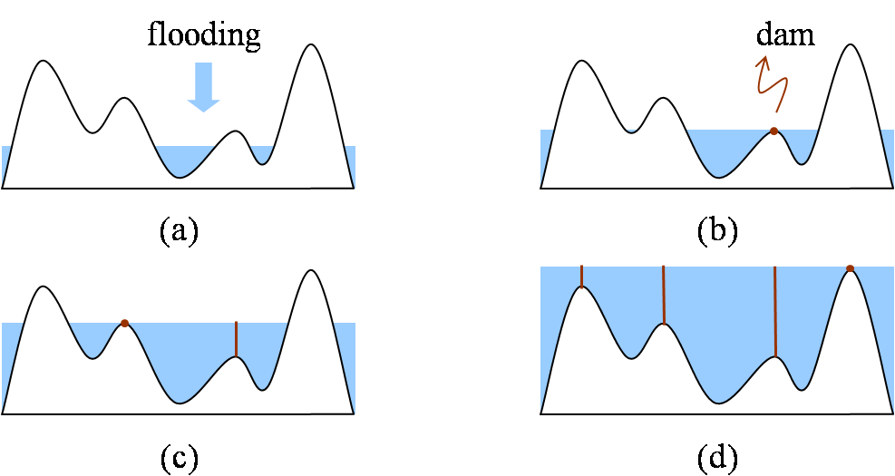

Fig: Watershed algorithm

Watershed algorithm with using marker:

1. Use a smoothing filter to preprocess the original image, then the action can minimize the large numbers of small spatial details.
2. Use two markers (internal markers and the external markers) to define the criteria of markers.
3. 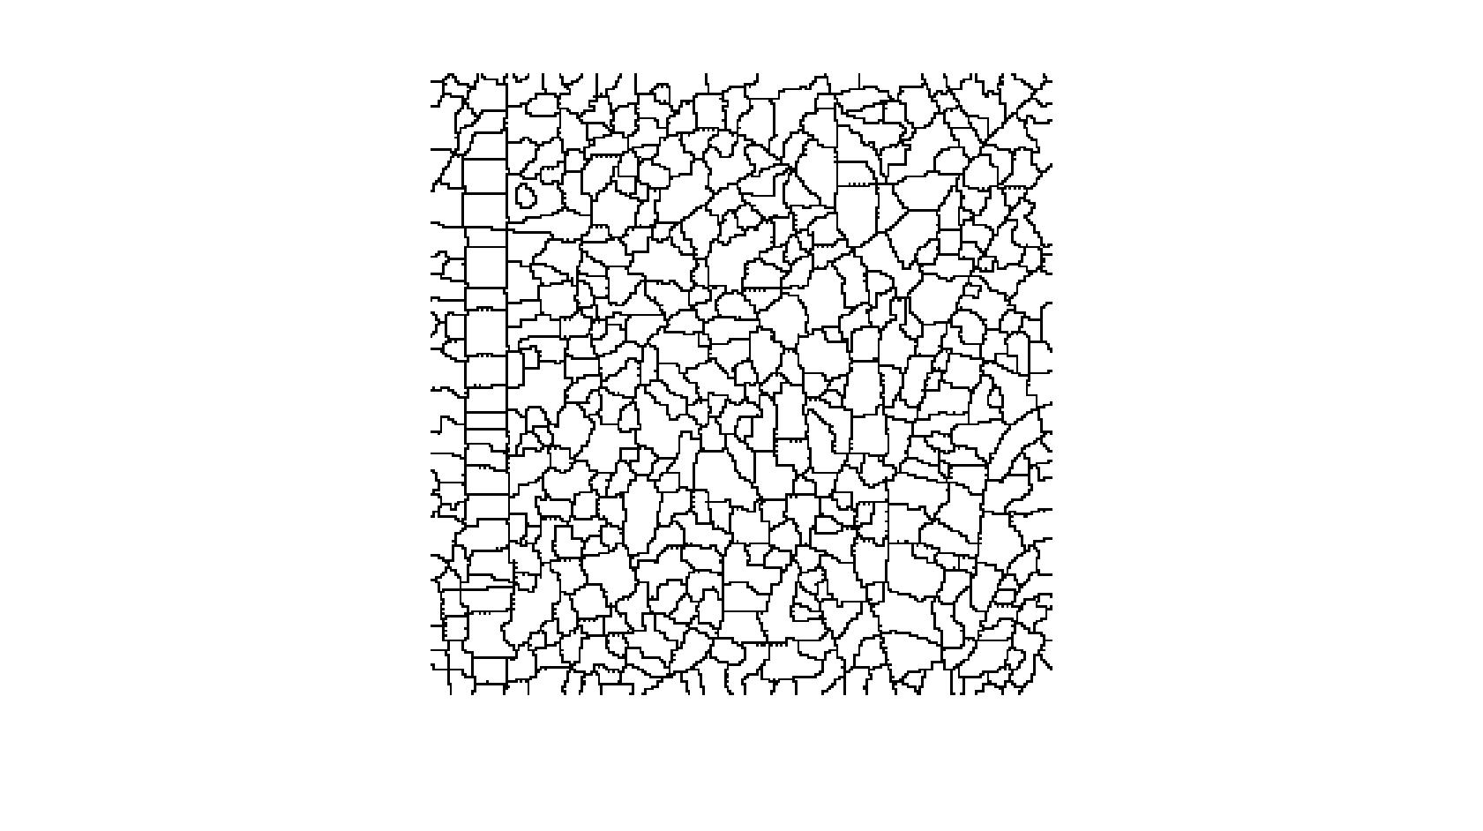 (b)
4. 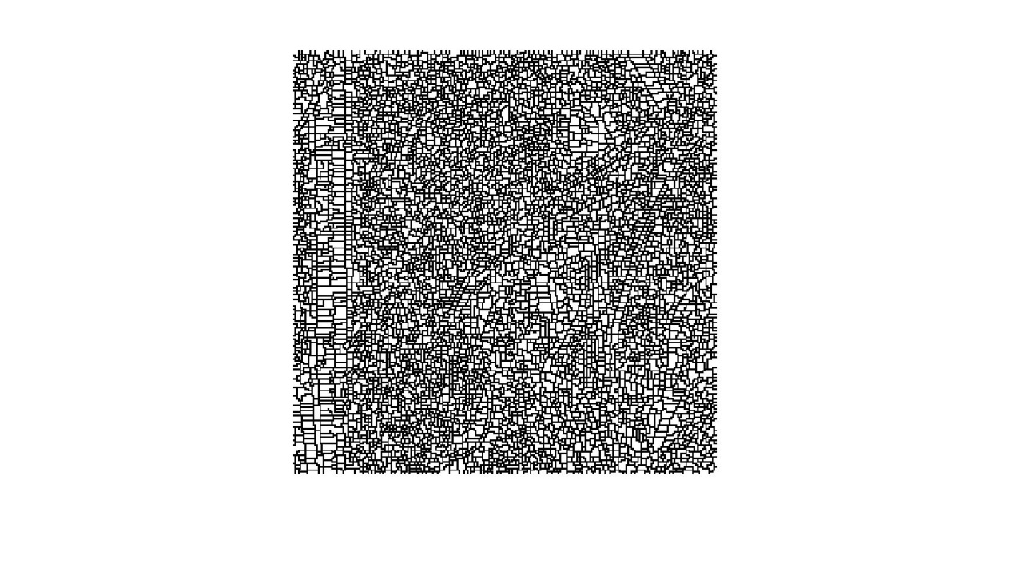 (b)

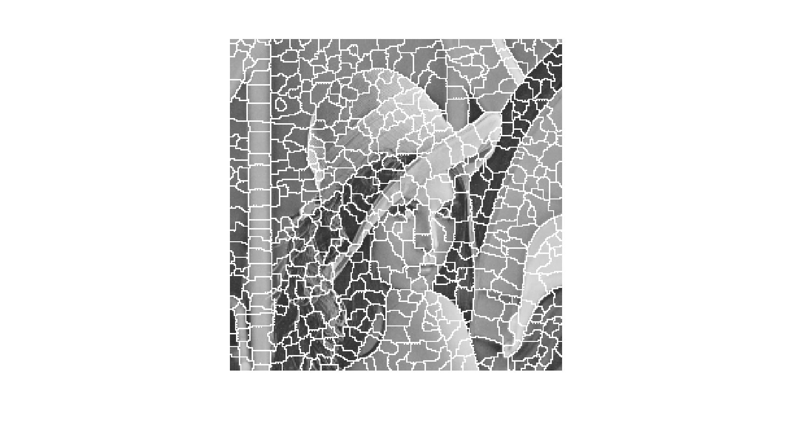 (c)

Fig: The simulation result of Watershed algorithm with MATLAB code; time: 1.23 seconds (a) pure watershed method, (b)(c) watershed method with improvement of gradient method.

The simulation result of watershed algorithm has an advantage that it is fast speed. At the same time, it has a critical over-segmented problem.

* 1. **The comparison of threshold technique and methods of region-based image segmentation and edge-based image segmentation**

|  |  |
| --- | --- |
| **The segmenting methods** | **Advantages** |
| **Threshold technique** | 1. Simplest method in segmenting images. |
| **\*Hierarchical clustering** | 1. The concept is simple. 2. The result is characteristic of strong correlation with the original image. (reliable) |
| **\*Partitional clustering**  **(K-means algorithm)** | 1. Fast speed. 2. The concept is simple, because numbers of cluster is fixed. |
| **\*Region growing** | 1. Can correctly separate the regions of same properties we define. 2. Clear edges, which means the good segmentation results. 3. The concept is simple. 4. Good shape matching of its results. 5. Can determine seed points and criteria 6. Can choose the multiple criteria simultaneously. |
| **\*Region merging and splitting** | 1. We split the image until get the resolution we need. 2. The splitting criteria and the merging criteria can use different criteria. |
| **\*Mean shift** | 1. Can separate the face and shoulders. |
| **△Watershed** | 1. Fast speed.   2. The large numbers of segmented region result is reliable. |

Table: The advantages of threshold technique and methods of region-based image segmentation and edge-based image segmentation.

|  |  |
| --- | --- |
| **The segmenting methods** | **Disadvantages** |
| **Threshold technique** | 1. Not involve the spatial information of the images, so it will bring about noise, blurred edges, or outlier in the images. |
| **\*Hierarchical clustering** | 1. Has a problem of computational time consuming, then it cannot be used for the large image. |
| **\*Partitional clustering**  **(K-means algorithm)** | 1. A problem of choice of numbers of cluster . 2. The different initial centroids will bring about the different results. 3. Cannot show the characteristic of database. |
| **\*Region growing** | 1. Has a problem of computational time consuming 2. Cannot differentiate the fine variation of the images. |
| **\*Region merging and splitting** | 1. Computation is extensive. 2. Has the problem of the blocky segmentation. |
| **\*Mean shift** | 1. Has a problem of computational time consuming  2. Cannot separate the other sections except the face and shoulders. |
| **△Watershed** | 1. Over-segmentation. |

Table: The disadvantages of threshold technique and methods of region-based image segmentation and edge-based image segmentation.

\*: means one method of region-based image segmentation.

△: means one method of edge-based image segmentation.

APPLICATIONS:

\* Medical imaging.

\* Recognition tasks.

\* EKSU on Google Maps.

\* Computer guided surgery.

\* Object detection such as face detection,

Brake detection etc.

\* Traffic control systems.

\* In sport scenes.

\* Content-based image retrieval.

\* Video surveillance.

# Image compression

The objective of **image compression** is to reduce irrelevance and redundancy of the image data in order to be able to store or [transmit](https://en.wikipedia.org/wiki/Data_transmission) data in an efficient form.

## Lossy and lossless Image compression

Lossless compression is preferred for archival purposes and often for medical imaging, technical drawings, [**clip art**](https://en.wikipedia.org/wiki/Clip_art), or comics.

Lossy compression methods, especially when used at low bit rates, introduce [compression artifacts](https://en.wikipedia.org/wiki/Compression_artifact)

Lossy methods are especially suitable for natural images such as photographs in applications where minor (sometimes imperceptible) loss of fidelity is acceptable to achieve a substantial reduction in bit rate. Lossy compression that produces negligible differences may be called visually lossless.

Methods for lossless image compression are:

* [Run-length encoding](https://en.wikipedia.org/wiki/Run-length_encoding) – used in default method in [PCX](https://en.wikipedia.org/wiki/PCX) and as one of possible in BMP, TGA, TIFF
* Area image compression
* [DPCM](https://en.wikipedia.org/wiki/DPCM) and Predictive Coding
* Entropy Encoding
* Adaptive dictionary algorithms such as [LZW](https://en.wikipedia.org/wiki/LZW) – used in GIF and TIFF
* Deflation – used in PNG,MNG and TIFF
* [Chain codes](https://en.wikipedia.org/wiki/Chain_code)

Methods for lossy compression:

* Reducing the color space to the most common colors in the image. The selected colors are specified in the color palette in the header of the compressed image. Each pixel just references the index of a color in the color palette; this method can be combined with dithering to avoid pasteurization.
* Chroma Subsampling. This takes advantage of the fact that the human eye perceives spatial changes of brightness more sharply than those of color, by averaging or dropping some of the chrominance information in the image.
* [Transform coding](https://en.wikipedia.org/wiki/Transform_coding). This is the most commonly used method. In particular, a [Fourier-related transform](https://en.wikipedia.org/wiki/List_of_Fourier-related_transforms) such as the Discrete Cosine Transform (DCT) is widely used: N.Ahmed, T. Natarajan and K.R.Rao, "Discrete cosine Transform," *IEEE Trans. Computers*, 90-93, Jan. 1974. The DCT is sometimes referred to as "DCT-II" in the context of a family of discrete cosine transforms; e.g., see discrete cosine transform. The more recently developed wavelet transform is also used extensively, followed by quantization and entropy encoding.
* Fractal Compression.

**Properties**

**Scalability** generally refers to a quality reduction achieved by manipulation of the bit stream or file (without decompression and re-compression). Other names for scalability are *progressive coding* or *embedded bit streams*. Despite its contrary nature, scalability also may be found in lossless codecs, usually in form of coarse-to-fine pixel scans. Scalability is especially useful for previewing images while downloading them (e.g., in a web browser) or for providing variable quality access to e.g., databases. There are several types of scalability:

* **Quality progressive** or layer progressive: The bit stream successively refines the reconstructed image.
* **Resolution progressive**: First encode a lower image resolution; then encode the difference to higher resolutions.
* **Component progressive**: First encode grey; then color.

**Region of interest coding**. Certain parts of the image are encoded with higher quality than others. This may be combined with scalability (encode these parts first, others later).

**Meta information**. Compressed data may contain information about the image which may be used to categorize, search, or browse images. Such information may include color and texture statistics, small preview images, and author or copyright information.

**Processing power**. Compression algorithms require different amounts of processing power to encode and decode. Some high compression algorithms require high processing power.

The quality of a compression method often is measured by the Peak Signal to Noise-Ratio. It measures the amount of noise introduced through a lossy compression of the image, however, the subjective judgment of the viewer also is regarded as an important measure, perhaps, being the most important measure.

Set image compression parameters

**Functions**

|  |  |
| --- | --- |
| [imgCompress](https://in.mathworks.com/help/matlab/ref/matlab.io.fits.imgcompress.html) | Compress HDU from one file into another |
| [isCompressedImg](https://in.mathworks.com/help/matlab/ref/matlab.io.fits.iscompressedimg.html) | Determine if current image is compressed |
| [setCompressionType](https://in.mathworks.com/help/matlab/ref/matlab.io.fits.setcompressiontype.html) | Set image compression type |
| [setHCompScale](https://in.mathworks.com/help/matlab/ref/matlab.io.fits.sethcompscale.html) | Set scale parameter for HCOMPRESS algorithm |
| [setHCompSmooth](https://in.mathworks.com/help/matlab/ref/matlab.io.fits.sethcompsmooth.html) | Set smoothing for images compressed with HCOMPRESS |
| [setTileDim](https://in.mathworks.com/help/matlab/ref/matlab.io.fits.settiledim.html) | Set tile dimensions |

**matlab.io.fits.imgCompress**

Compress HDU from one file into another

**Syntax**

imgCompress(infptr,outfptr)

**Description**

imgCompress(infptr,outfptr) initializes the output HDU, copies all the keywords, and loops through the input image, compressing the data and writing the compressed data to the output HDU.

This function corresponds to the fits\_img\_compress function in the CFITSIO library C API.

**Examples**

Import matlab.io.\*

infptr = fits.openFile('tst0012.fits');

outfptr = fits.createFile('myfile.fits');

fits.setCompressionType(outfptr,'rice');

fits.imgCompress(infptr,outfptr);

fits.closeFile(infptr);

fits.closeFile(outfptr);

# matlab.io.fits.isCompressedImg

Determine if current image is compressed

## Syntax

TF = isCompressedImg(fptr)

## Description

TF = isCompressedImg(fptr) returns true if the image in the current HDU is compressed.

This function corresponds to the fits\_is\_compressed\_image function in the CFITSIO library C API.

## Examples

Import matlab.io.\*

fptr = fits.openFile('tst0012.fits');

bool = fits.isCompressedImg(fptr);

fits.closeFile(fptr);

**matlab.io.fits.setCompressionType**

Set image compression type

**Syntax**

setCompressionType(fptr,comptype)

**Description**

setCompressionType(fptr,comptype) specifies the image compression algorithm that should be used when writing a FITS image.

Supported values for comptype include:

|  |
| --- |
| 'GZIP' |
| 'GZIP2' |
| 'RICE' |
| 'PLIO' |
| 'HCOMPRESS' |
| 'NOCOMPRESS' |

This function corresponds to the fits\_set\_compression\_type function in the CFITSIO library C API.

**Examples**

import matlab.io.\*

fptr = fits.createFile('myfile.fits');

fits.setCompressionType(fptr,'GZIP2');

fits.createImg(fptr,'long\_img',[256 512]);

data = reshape(1:256\*512,[256 512]);

data = int32(data);

fits.writeImg(fptr,data);

fits.closeFile(fptr);

fitsdisp('myfile.fits','mode','full');

# matlab.io.fits.setHCompScale

Set scale parameter for HCOMPRESS algorithm

## Syntax

setHCompScale(fptr,scale)

## Description

setHCompScale(fptr,scale) sets the scale parameter to be used with the HCOMPRESS compression algorithm. Setting the scale parameter causes the algorithm to operate in lossy mode.

This function corresponds to the fits\_set\_hcomp\_scale function in the CFITSIO library C API.

## Examples

import matlab.io.\*

data = 50\*ones(256,512,'double') + 10 \* rand([256 512]);

fptr = fits.createFile('myfile.fits');

fits.setCompressionType(fptr,'HCOMPRESS\_1');

fits.setHCompScale(fptr,2.5);

fits.createImg(fptr,'double\_img',[256 512]);

fits.writeImg(fptr,data);

fits.closeFile(fptr);

fitsdisp('myfile.fits','mode','full');

# matlab.io.fits.setHCompSmooth

Set smoothing for images compressed with HCOMPRESS

## Syntax

setHCompSmooth(fptr,smooth)

## Description

setHCompSmooth(fptr,smooth) sets the smoothing to be used when compressing an image with the HCOMPRESS algorithm. Setting either the scale or smoothing parameter causes the algorithm to operate in lossy mode.

This function corresponds to the fits\_set\_hcomp\_smooth function in the CFITSIO library C API.

## Examples

import matlab.io.\*

data = int32(50\*ones(256,512,'double') + 10 \* rand([256 512]));

fptr = fits.createFile('myfile.fits');

fits.setCompressionType(fptr,'HCOMPRESS');

fits.setHCompSmooth(fptr,1);

fits.createImg(fptr,'long\_img',[256 512]);

fits.writeImg(fptr,data);

fits.closeFile(fptr);

fitsdisp('myfile.fits','mode','full');

# matlab.io.fits.setTileDim

Set tile dimensions

## Syntax

fits.setTileDim(fptr,tiledims)

## Description

fits.setTileDim(fptr,tiledims) specifies the size of the image compression tiles to be used when creating a compressed image.

This function corresponds to the fits\_set\_tile\_dim function in the CFITSIO library C API.

## Examples

import matlab.io.\*

fptr = fits.createFile('myfile.fits');

fits.setCompressionType(fptr,'RICE\_1');

fits.setTileDim(fptr,[64 128]);

fits.createImg(fptr,'byte\_img',[256 512]);

data = ones(256,512,'uint8');

fits.writeImg(fptr,data);

fits.closeFile(fptr);

fitsdisp('myfile.fits','mode','full');

**MILESTONE 3**

**Image Segmentation**

* [Non-contextual thresholding](https://www.cs.auckland.ac.nz/courses/compsci773s1c/lectures/ImageProcessing-html/topic3.htm#thresh)
  + [Simple thresholding](https://www.cs.auckland.ac.nz/courses/compsci773s1c/lectures/ImageProcessing-html/topic3.htm#simple)
  + [Adaptive thresholding](https://www.cs.auckland.ac.nz/courses/compsci773s1c/lectures/ImageProcessing-html/topic3.htm#adaptive)
  + [Colour thresholding](https://www.cs.auckland.ac.nz/courses/compsci773s1c/lectures/ImageProcessing-html/topic3.htm#colour)
* [Contextual segmentation: Region growing](https://www.cs.auckland.ac.nz/courses/compsci773s1c/lectures/ImageProcessing-html/topic3.htm#region)
  + [Pixel connectivity](https://www.cs.auckland.ac.nz/courses/compsci773s1c/lectures/ImageProcessing-html/topic3.htm#connect)
  + [Region similarity](https://www.cs.auckland.ac.nz/courses/compsci773s1c/lectures/ImageProcessing-html/topic3.htm#similarity)
  + [Region growing](https://www.cs.auckland.ac.nz/courses/compsci773s1c/lectures/ImageProcessing-html/topic3.htm#growing)
  + [Split-and-merge segmentation](https://www.cs.auckland.ac.nz/courses/compsci773s1c/lectures/ImageProcessing-html/topic3.htm#split)
* [Texture segmentation: Spectral features](https://www.cs.auckland.ac.nz/courses/compsci773s1c/lectures/ImageProcessing-html/topic3.htm#texture)
* [References](https://www.cs.auckland.ac.nz/courses/compsci773s1c/lectures/ImageProcessing-html/topic3.htm#refs)

**Segmentation** partitions an image into distinct regions containing each pixels with similar attributes. To be meaningful and useful for image analysis and interpretation, the regions should strongly relate to depicted objects or features of interest. Meaningful segmentation is the first step from low-level image processing transforming a grey scale or colour image into one or more other images to high-level image description in terms of features, objects, and scenes. The success of image analysis depends on reliability of segmentation, but an accurate partitioning of an image is generally a very challenging problem.

Segmentation techniques are either *contextual* or *non-contextual*. The latter take no account of spatial relationships between features in an image and group pixels together on the basis of some global attribute, e.g. grey level or colour. Contextual techniques additionally exploit these relationships, e.g. group together pixels with similar grey levels and close spatial locations.

**Non-contextual thresholding**

**Thresholding** is the simplest non-contextual segmentation technique. With a single threshold, it transforms a greyscale or colour image into a binary image considered as a binary region map. The binary map contains two possibly disjoint regions, one of them containing pixels with input data values smaller than a threshold and another relating to the input values that are at or above the threshold. The former and latter regions are usually labelled with zero (0) and non-zero (1) labels, respectively. The segmentation depends on image property being threshold and on how the threshold is chosen.

Generally, the non-contextual thresholding may involve two or more thresholds as well as produce more than two types of regions such that ranges of input image signals related to each region type are separated with thresholds. The question of thresholding is how to automatically determine the threshold value.

**Simple thresholding**

The most common image property to threshold is pixel grey level: *g(x, y)* = 0 if *f(x, y) < T* and *g(x, y)* = 1 if *f(x, y) ≥ T*, where *T* is the threshold. Using two thresholds, *T*1 < *T*1, a range of grey levels related to region 1 can be defined: *g(x, y)* = 0 if *f(x , y) < T*1 OR *f(x, y) > T*2 and *g(x, y)* = 1 if *T*1 ≤ *f(x ,y)* ≤ *T*2.

|  |  |  |
| --- | --- | --- |
| https://www.cs.auckland.ac.nz/courses/compsci773s1c/lectures/ImageProcessing-html/boa1gl.gif | https://www.cs.auckland.ac.nz/courses/compsci773s1c/lectures/ImageProcessing-html/boa-hist.gif | |
| Greyscale image "Boat" | Its grey level histogram | |
| https://www.cs.auckland.ac.nz/courses/compsci773s1c/lectures/ImageProcessing-html/boa1bin026.gif | https://www.cs.auckland.ac.nz/courses/compsci773s1c/lectures/ImageProcessing-html/boa1bin133.gif | https://www.cs.auckland.ac.nz/courses/compsci773s1c/lectures/ImageProcessing-html/boa1bin235.gif |
| Binary regions for *T* = 26 | Binary regions for *T* = 133 | Binary regions for *T* = 235 |
| https://www.cs.auckland.ac.nz/courses/compsci773s1c/lectures/ImageProcessing-html/baboon_grey.gif | https://www.cs.auckland.ac.nz/courses/compsci773s1c/lectures/ImageProcessing-html/baboon-histo.gif | https://www.cs.auckland.ac.nz/courses/compsci773s1c/lectures/ImageProcessing-html/baboon_thresh153.gif |
| Grey scale image "Baboon" | Its grey level histogram | Binary regions for *T* = 159 |

The main problems are whether it is possible and, if yes, how to choose an adequate threshold or a number of thresholds to separate one or more desired objects from their background. In many practical cases the simple thresholding is unable to segment objects of interest, as shown in the above images.

A general approach to thresholding is based on assumption that images are *multimodal*, that is, different objects of interest relate to distinct peaks (or modes) of the 1D signal histogram. The thresholds have to optimally separate these peaks in spite of typical overlaps between the signal ranges corresponding to individual peaks. A threshold in the valley between two overlapping peaks separates their main bodies but inevitably detects or rejects falsely some pixels with intermediate signals. The optimal threshold that minimises the expected numbers of false detections and rejections may not coincide with the lowest point in the valley between two overlapping peaks:

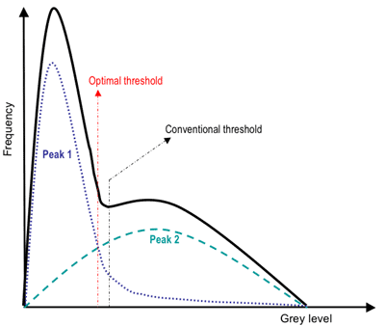

**Adaptive thresholding**

Since the threshold separates the background from the object, the adaptive separation may take account of empirical probability distributions of object (e.g. dark) and background (bright) pixels. Such a threshold has to equalise two kinds of expected errors: of assigning a background pixel to the object and of assigning an object pixel to the background. More complex adaptive thresholding techniques use a spatially varying threshold to compensate for local spatial context effects (such a spatially varying threshold can be thought as a background normalisation).

A simple iterative adaptation of the threshold is based on successive refinement of the estimated peak positions. It assumes that (*i*) each peak coincides with the mean grey level for all pixels that relate to that peak and (*ii*) the pixel probability decreases monotonically on the absolute difference between the pixel and peak values both for an object and background peak. The classification of the object and background pixels is done at each iteration *j* by using the threshold *Tj* found at previous iteration. Thus, at iteration *j*, each grey level *f(x, y)* is assigned first to the object or background class (region) if *f(x, y)* ≤ *Tj* or *f(x, y)* > *Tj*, respectively. Then, the new threshold, *Tj*+1 = 0.5(j*o*b + μ*j*,bg) where j*o*b and μ*j*,bg denote the mean grey level at iteration *j* for the found object and background pixels, respectively:

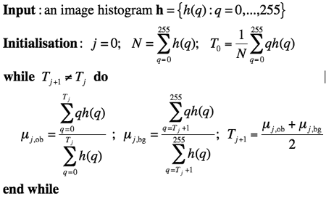

**Colour thresholding**

Color segmentation may be more accurate because of more information at the pixel level comparing to grey scale images. The standard Red-Green-Blue (RGB) colour representation has strongly interrelated colour components, and a number of other colour systems (e.g. HSI Hue-Saturation-Intensity) have been designed in order to exclude redundancy, determine actual object / background colours irrespectively of illumination, and obtain more stable segmentation. An example below (from http://www.matrix-vision.com/products/software) shows that colour thresholding can focus on an object of interest much better than its grey scale analogue:

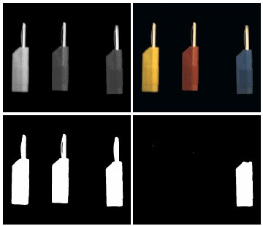  
Grey scale vs. colour thresholding

Segmentation of colour images involve a *partitioning* of the colour space, i.e. RGB or HSI space. One simple approach is based on some reference (or dominant) colour (R0, G0, B0) and thresholding of Cartesian distances to it from every pixel colour **f**(*x, y*) = (R(*x, y*),G(*x, y*),B(*x, y*)):



where *g(x,y)* is the binary region map after thresholding. This thresholding rule defines a sphere in RGB space, centred on the reference colour. All pixels inside or on the sphere belong to the region indexed with 1 and all other pixels are in the region 0.

Also, there can be an ellipsoidal decision surface if independent distance thresholds are specified for the R, G, and B components. Generally, colour segmentation, just as the grey scale one, may be based on the analysis of 3D colour histograms or their more convenient 2D projections. A colour histogram is built by partitioning of the colour space onto a fixed number of bins such that the colours within each bin are considered as the same colour. An example below of the partitioned 11×11×11 RGB colour space is from (http://www.owlnet.rice.edu/~elec301/Projects02/artSpy/color.html):

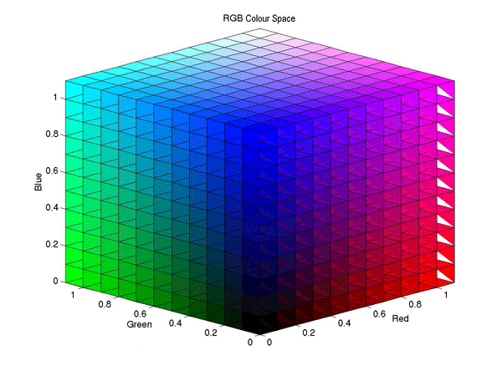

How fine should be the partitioning depends on the application domain? In many cases colour segmentation exploits only a few dominant colours corresponding to distinct peaks of the pixel-wise colour distribution (both the images and histograms below are from ij-plugins.sourceforge.net/ij-vtk/color-space/):

|  |  |
| --- | --- |
| https://www.cs.auckland.ac.nz/courses/compsci773s1c/lectures/ImageProcessing-html/baboon_small.jpg | https://www.cs.auckland.ac.nz/courses/compsci773s1c/lectures/ImageProcessing-html/baboon-colourhist6x6x6.gif |
| Colour image "Baboon" | Its colour 6×6×6 histogram (sphere-size-coded bin values) |
| https://www.cs.auckland.ac.nz/courses/compsci773s1c/lectures/ImageProcessing-html/clown.jpg | https://www.cs.auckland.ac.nz/courses/compsci773s1c/lectures/ImageProcessing-html/clown-colourhist6x6x6.gif |
| Colour image "Clown" | Its colour 6×6×6 histogram (sphere-size-coded bin values) |

If a chosen colour space separates colourless intensity values from intensity-independent colour components (such as hue and saturation or normalised red / blue colors), colour segmentation can be based on a few pre-selected colours, e.g. on the eight primary colours (black, red, green, blue, yellow, cyan, magenta, white). An example below shows a digitised picture of the Rembrandt's canvas "Doctor Nicolas Tulip’s Demonstration of the Anatomy of the Arm" (1632; Mauritshuis Museum, The Hague, The Netherlands), its 8-bin histogram of the primary colours, and the corresponding colour regions:

|  |  |  |
| --- | --- | --- |
| https://www.cs.auckland.ac.nz/courses/compsci773s1c/lectures/ImageProcessing-html/rcol-rembrandt.gif | https://www.cs.auckland.ac.nz/courses/compsci773s1c/lectures/ImageProcessing-html/rcolhist-rembrandt8.gif | https://www.cs.auckland.ac.nz/courses/compsci773s1c/lectures/ImageProcessing-html/rcol-rembrandt8.gif |
| Digitised Rembrandt's canvas | Colour 8-bin histogram | Regions of the primary colours |
| (www.abcgallery.com/R/rembrandt/) | (http://rsb.info.nih.gov/ij/plugins/color-inspector.html) | |

More efficient adaptive thresholding of grey scale images can be extended to colour images, too, by replacing mean grey levels for each colour region with its mean colors, e.g. RGB-vectors with the mean component values.

**Contextual segmentation: Region growing**

Non-contextual thresholding groups pixels with no account of their relative locations in the image plane. **Contextual segmentation** can be more successful in separating individual objects because it accounts for closeness of pixels that belong to an individual object. Two basic approaches to contextual segmentation are based on signal *discontinuity* or *similarity*. Discontinuity-based techniques attempt to find complete boundaries enclosing relatively uniform regions assuming abrupt signal changes across each boundary. Similarity-based techniques attempt to directly create these uniform regions by grouping together connected pixels that satisfy certain similarity criteria. Both the approaches mirror each other, in the sense that a complete boundary splits one region into two.

**Pixel connectivity**

**Pixel connectivity** is defined in terms of pixel neighbourhoods. A normal rectangular sampling pattern producing a finite arithmetic lattice {(*x,y*): *x* = 0, 1, ..., *X*−1; *y* = 0, 1, ..., *Y*−1} supporting digital images allows us to define two types of neighbourhood surrounding a pixel. A **4-neighbourhood** {(*x*−1,*y*), (*x*,*y*+1), (*x*+1,*y*), (*x*,*y*−1)} contains only the pixels above, below, to the left and to the right of the central pixel (*x,y*). An **8-neighbourhood** adds to the 4-neighbourhood four diagonal neighbours: {(*x*−1,*y*−1),(*x*−1,*y*), (*x*−1,*y*+1), (*x*,*y*+1), (*x*+1,*y*+1), (*x*+1,*y*), (*x*+1,*y*−1), (*x*,*y*−1)}.

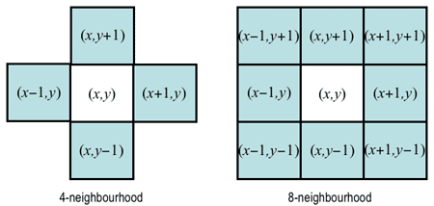

A **4-connected path** from a pixel *p*1 to another pixel *pn* is defined as the sequence of pixels {*p*1, *p*2, ..., *pn*} such that *pi*+1 is a 4-neighbour of *pi* for all *i* = 1, ..., *n*−1. The path is **8-connected** if *pi*+1 is an 8-neighbour of *pi*. A set of pixels is a **4-connected region** if there exists at least one 4-connected path between any pair of pixels from that set. The **8-connected region** has at least one 8-connected path between any pair of pixels from that set.

One of the simplest and most common algorithms for labelling connected regions after grey scale or colour thresholding exploits the "grassfire" or "wave propagation" principle: after a "fire" or "wave" starts at one pixel, it propagates to any of the pixel's 4- or 8-neighbours detected by thresholding. Each already visited (i.e. "burnt away" or "wet") pixel cannot be visited again, and after the entire connected region is labelled, its pixels are assigned a region number, and the procedure continues to search for the next connected region. Magenta and yellow stars below indicate the fire, or wave front and the burnt away pixels, respectively. To label a region, the fire starts from its first chosen pixel:

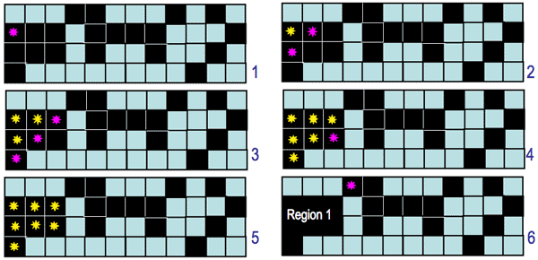

The 4- and 8-connectivity produce different segmentation results:

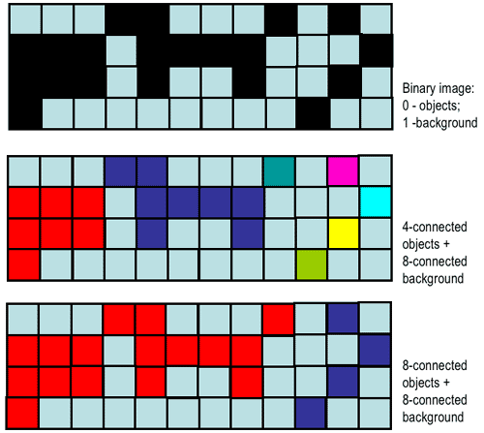

Moreover, each definition leads to contradictions between the discrete and continuous cases. For example, an one-pixel-wide vertical or horizontal 8-connected line separates two 8-connected regions but this separation does not hold after the line is only slightly rotated with respect to the image lattice:

|  |  |
| --- | --- |
| https://www.cs.auckland.ac.nz/courses/compsci773s1c/lectures/ImageProcessing-html/8-connect-1.gif | https://www.cs.auckland.ac.nz/courses/compsci773s1c/lectures/ImageProcessing-html/8-connect-2.gif |

At the same time, the like 4-connected line breaks into disjoint pieces after such a rotation:

|  |  |
| --- | --- |
| https://www.cs.auckland.ac.nz/courses/compsci773s1c/lectures/ImageProcessing-html/8-connect-1.gif | https://www.cs.auckland.ac.nz/courses/compsci773s1c/lectures/ImageProcessing-html/8-connect-3.gif |

Modern **digital geometry** has developed theoretically justified approaches to escape these problems. In many practical cases, the connectivity is simply defined variously for objects (foreground pixels) and background, e.g. 4-connectivity for objects and 8-connectivity for background or vice versa:

|  |  |  |
| --- | --- | --- |
| https://www.cs.auckland.ac.nz/courses/compsci773s1c/lectures/ImageProcessing-html/drawing.gif | https://www.cs.auckland.ac.nz/courses/compsci773s1c/lectures/ImageProcessing-html/drawing-label-4.gif | https://www.cs.auckland.ac.nz/courses/compsci773s1c/lectures/ImageProcessing-html/drawing-label-8.gif |
| Binary image 64×64 (zoom by a factor of 5) | 86 foreground 4-connected regions | 10 foreground 8-connected regions |
| (http://www.dca.fee.unicamp.br/projects/khoros/mmach/tutor/toolbox/basicl/labeling/front-page.html) | | |

**Region similarity**

The uniformity or non-uniformity of pixels to form a connected region is represented by a **uniformity predicate**, i.e. a logical statement, or condition being true if pixels in the regions are similar with respect to some property (colour, grey level, edge strength, etc.). A common predicate restricts signal variations over a neighbourhood: the predicate *P(R)*, where *R* denotes a connected region, is TRUE if |*f(x, y) − f(x + ξ, y + η)*| ≤ Δ and FALSE otherwise (here, *(x, y)* and *(x + ξ, y +η)* are the coordinates of neighbouring pixels in region *R*. This predicate does not restrict the grey level variation within a region because small changes in signal values can accumulate over the region.

Intra-region signal variations can be restricted with a similar predicate: *P(R)* = TRUE if |*f(x, y) − &muR*| ≤ &Delta and FALSE otherwise where (*x, y*) is a pixel from the region *R* and μ*R* is the mean value of signals *f(x, y)* over the entire region *R*.

**Region growing**

The bottom-up **region growing** algorithm starts from a set of seed pixels defined by the user and sequentially adds a pixel to a region provided that the pixel has not been assigned to any other region, is a neighbour of that region, and its addition preserves uniformity of the growing region.

|  |  |  |
| --- | --- | --- |
| https://www.cs.auckland.ac.nz/courses/compsci773s1c/lectures/ImageProcessing-html/image29-brown.gif | https://www.cs.auckland.ac.nz/courses/compsci773s1c/lectures/ImageProcessing-html/seed1-29-brown.gif | https://www.cs.auckland.ac.nz/courses/compsci773s1c/lectures/ImageProcessing-html/result1-29-brown.gif |
| Grey scale image | Seed regions | Region growing results |
| (http://www.lems.brown.edu/~msj/cs292/assign5/segment.html) | | |

Such segmentation is simple but unstable. It is very sensitive to a chosen uniformity predicate, i.e. small changes of the uniformity threshold may result in large changes of the regions found. Also, very different segmentation maps are obtained under different routes of scanning an image, different modes of exhausting neighbours of each region, different seeds, and different types of pixel connectivity.

|  |  |  |
| --- | --- | --- |
| https://www.cs.auckland.ac.nz/courses/compsci773s1c/lectures/ImageProcessing-html/mrhead.gif | https://www.cs.auckland.ac.nz/courses/compsci773s1c/lectures/ImageProcessing-html/sm4conn.gif | https://www.cs.auckland.ac.nz/courses/compsci773s1c/lectures/ImageProcessing-html/sm8conn.gif |
| Grey scale image (zoom by a factor of 2) | 4-connected region growing | 8-connected region growing |
| (http://www.comp.leeds.ac.uk/ai21/examples/images/rgrow.html) | | |
| https://www.cs.auckland.ac.nz/courses/compsci773s1c/lectures/ImageProcessing-html/image11-brown.gif | https://www.cs.auckland.ac.nz/courses/compsci773s1c/lectures/ImageProcessing-html/seed1-11-brown.gif | https://www.cs.auckland.ac.nz/courses/compsci773s1c/lectures/ImageProcessing-html/result1-11-brown.gif |
| Greyscale image | Seed regions: variant 1 | Region growing results |
|  | https://www.cs.auckland.ac.nz/courses/compsci773s1c/lectures/ImageProcessing-html/seed2-11-brown.gif | https://www.cs.auckland.ac.nz/courses/compsci773s1c/lectures/ImageProcessing-html/result2-11-brown.gif |
|  | Seed regions: variant 2 | Region growing results |
| (http://www.lems.brown.edu/~msj/cs292/assign5/segment.html) | | |

Generally, a "good" complete segmentation must satisfy the following criteria:

1. All pixels have to be assigned to regions.
2. Each pixel has to belong to a single region only.
3. Each region is a connected set of pixels.
4. Each region has to be uniform with respect to a given predicate.
5. Any merged pair of adjacent regions has to be non-uniform.

Region growing satisfies the 3rd and 4th criteria, but not the others. The first two criteria are not satisfied because, in general, the number of seeds may not be sufficient to create a region for every pixel. The 5th criterion may not hold because the regions grown from two nearby seeds are always regarded as distinct, even if those seeds are defined within a potentially uniform part of the image.

**Split-and-merge segmentation**

The top-down **split-and-merge** algorithm considers initially the entire image to be a single region and then iteratively splits each region into sub regions or merges adjacent regions until all regions become uniform or until the desired number of regions have been established.

A common splitting strategy for a square image is to divide it recursively into smaller and smaller quadrants until, for any region *R*, the uniformity predicate *P(R)* is TRUE. The strategy builds a top-down *quad tree*: if *P*(image) is FALSE, the image is divided into four quadrants; if *P*(quadrant) is FALSE, the quadrant is divided into sub quadrants; and so on:

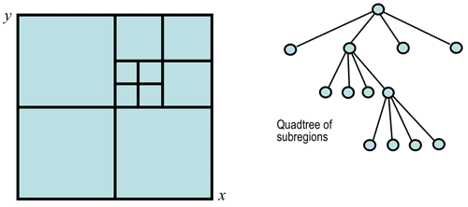

The splitting stage alternates with a merging stage, in which two adjacent regions *Ri* and *Rj* are combined into a new, larger region if the uniformity predicate for the union of these two regions, *P(Ri ∪ Rj)*, is TRUE.

**Texture segmentation: Spectral features**

Grey level or colour pixel values by themselves are not sufficient for segmenting natural highly-textured images like those shown below:

|  |  |  |
| --- | --- | --- |
| https://www.cs.auckland.ac.nz/courses/compsci773s1c/lectures/ImageProcessing-html/h103__7a-tamas.gif | https://www.cs.auckland.ac.nz/courses/compsci773s1c/lectures/ImageProcessing-html/h103-histo.gif | https://www.cs.auckland.ac.nz/courses/compsci773s1c/lectures/ImageProcessing-html/h103__7a-tamas-thresh.gif |
| Textured collage | Grey-level histogram | Segmentation by thresholding |

The above two regions (a black object and white background) obtained by simple thresholding are completely meaningless. To find meaningful regions containing different types of homogeneous textures, specific texture measures (features) have to be used like, for example, local spatial signal statistics:

|  |  |
| --- | --- |
| https://www.cs.auckland.ac.nz/courses/compsci773s1c/lectures/ImageProcessing-html/h103__7a-tamas.gif | https://www.cs.auckland.ac.nz/courses/compsci773s1c/lectures/ImageProcessing-html/h103__7c-tamas.gif |
| Textured collage | Segmentation using local features |
| (http://www.sztaki.hu/~sziranyi/textu-iu.html) | |
| https://www.cs.auckland.ac.nz/courses/compsci773s1c/lectures/ImageProcessing-html/mikes2.gif | |
| Textured collage, actual region map, and segmentation using local features | |
| (http://www.ercim.org/publication/Ercim\_News/enw64/mikes.html | |

Texture is a spatial property that characterises groups of pixels. A local measure of texture is therefore computed over a neighbourhood. An example of the simplest statistical measure is the *variance* of grey levels in a square *n×n* neighbourhood centred on a pixel:

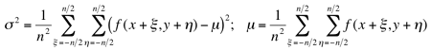

The "variance" image presents scaled standard deviations σ for each pixel; bright regions in this image signify high local variance of grey levels:

|  |  |
| --- | --- |
| https://www.cs.auckland.ac.nz/courses/compsci773s1c/lectures/ImageProcessing-html/baboon_grey.gif | https://www.cs.auckland.ac.nz/courses/compsci773s1c/lectures/ImageProcessing-html/baboon-variance.gif |
| Grey scale image "Baboon" | Variance image (7×7 window) |
| https://www.cs.auckland.ac.nz/courses/compsci773s1c/lectures/ImageProcessing-html/baboon-var-histo.gif | https://www.cs.auckland.ac.nz/courses/compsci773s1c/lectures/ImageProcessing-html/baboon-var-thr63.gif |
| Histogram of the variance image | Variance thresholding: *T*=63 |

For most of natural textures, simple statistical measures are of little use. If two textures of interest are periodic, they might be separated in the frequency domain by comparing the spectra of small samples taken from the two patterns. Spectral segmentation techniques typically use the radially or angularly integrated power spectrum of a region in an image. Radial integration sums power values within a ring of radius *r* and width Δ*r*. Angular integration sums power values within a sector defined by a radius, *r*, an orientation, θ, and an angular width, Δθ. The ring-based measurement relates to the texture scale: a concentration of power at small or large radii signifies coarse or fine texture, respectively. The sector-based measurement relates to texture orientation: a texture oriented in a direction φ results in high power for a sector at angle θ = φ + π/2.